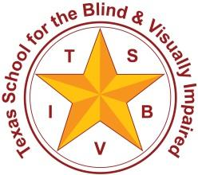 | Texas Deafblind Outreach  A division of Texas School for the Blind & Visually Impaired  Outreach Programs  www.tsbvi.edu | 512-454-8631 | 1100 W. 45th St. | Austin, TX 78756
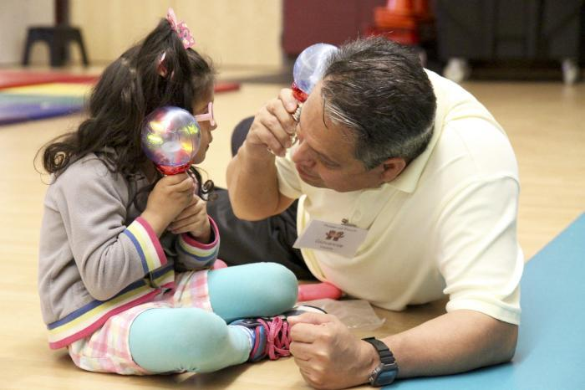
A person with vision loss who also has hearing loss may have limited access to information from the environment, which makes learning difficult. When this occurs the child may be considered deafblind. Specialized accommodations and supports in school enable children who are deafblind to learn, communicate, and interact with the world.

The Texas Deafblind Project, located at Texas School for the Blind & Visually Impaired in Austin, is a federally funded grant program whose mission is to support individuals who are DeafBlind (birth through age 22) and their families. As part of the TSBVI Outreach Programs, we partner and work in collaboration with the public and charter schools and Education Service Centers of Texas. To learn more about our Project or request a service, visit us on the web at https://tinyurl.com/tsbvi-deafblindproject or contact us at 512-454-8631.

Services
- Free newsletter about visual impairments and deafblind, TX Sense Abilities
- Support, information, and training statewide online and in person for families and professionals
- School consultation and technical assistance for families, teachers, paraprofessionals, and programs serving students (birth-22) who are deafblind
- Information and referral for families and professionals
- Funding assistance for families to attend training
- Access to technology loans for schools to try out assistive technology before purchase

Texas Deafblind Project Staff
- Kate Borg, Director of Outreach, borgk@tsbvi.edu, 512-206-9242
- Suzanne Slade, Administrative Assistant, slades@tsbvi.edu, 512-206-9103
- Brian Sobeck, DeafBlind Child Count, sobeckb@tsbvi.edu, 512-206-9225
- Edgenie Bellah, Family Engagement Consultant, bellahe@tsbvi.edu, 512-206-9423
- Deanna Peterson, Early Childhood Consultant, petersond@tsbvi.edu, 512-206-9330
- Kaycee Bennett, Education Consultant, bennettk@tsbvi.edu, 512-287-0726
- Adam Graves, Education Consultant, gravesa@tsbvi.edu, 512-206-9314
- Chris Montgomery, Education Consultant, montgomeryc@tsbvi.edu, 512-206-9359
- Chris Tabb, Orientation and Mobility Consultant, tabbc@tsbvi.edu, 512-206-9226
- David Wiley, Transition Consultant, wileyd@tsbvi.edu, 512-206-9219

This project is supported by the U.S. Department of Education, Special Education Programs (OSEP). Opinions expressed here are the authors’ and do not necessarily represent the position of the Department of Education.

