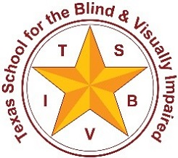
Texas School for the Blind & Visually Impaired

Outreach Programs
www.tsbvi.edu | 512-454-8631 | 1100 W. 45th St. | Austin, TX 78756

Sound Travels

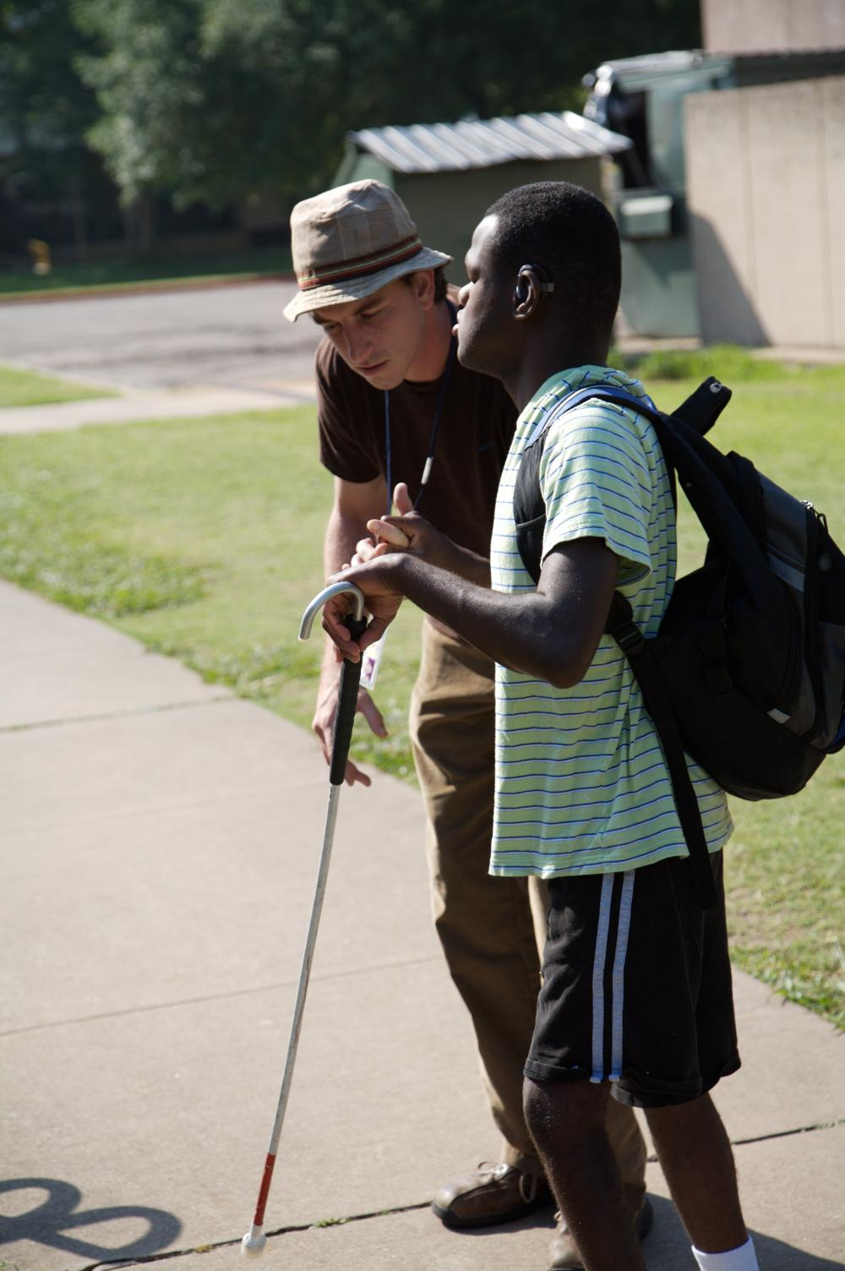
Texas School for the Blind and Visually Impaired
Outreach Programs - Texas Deafblind Project

Contents

About Sound Travels 1
Environmental Sounds Considerations for the Audiologist and the Orientation and Mobility Specialist 2
Collaboration Tool for Environmental Sounds 5
Developing Auditory Skills 11
Delineation of Roles Related to Safe and Independent Travel for the Student with Deafblindness 13
Tip Sheet for the Teacher of the Deaf and Hard of Hearing 16
Sample Letter to the Audiologist 20

About Sound Travels
Sound Travels is a guidance document designed to help a team address the needs of a student who is deafblind in the area of orientation and mobility. It came about through the collaboration of several members of the Texas Deafblind Project and an audiologist as they tried to develop assessment guidelines to assist the team in fitting a hearing aid for a student who is deafblind. Their discussion and collaboration identified some specific challenges that must be met by the team to insure appropriate amplification and instruction is in place for a student who is deafblind.
Students who are deafblind have needs that are different from a person who is deaf or hard of hearing when it comes to fitting a hearing aid or assistive listening device. This is especially true when considering the student’s needs related to Orientation and Mobility. Students who are blind or visually impaired rely on their hearing for localizing sound, identifying sound, and using sound as a way to orient to their surroundings. Hearing aids, if not configured for these requirements, can impede rather than support the development of orientation and mobility skills and reduce safety for the student.
We would like to thank all of the individuals who helped to develop and review these materials.

Contributors
Edgenie Bellah, COMS / Family Engagement Coordinator, Texas Deafblind Project, Texas School for the Blind & Visually Impaired, Austin, TX
Robbie Blaha, M.ED.,/TVI/TDHH/ Education Consultant, Texas Deafblind Project, Texas School for the Blind & Visually Impaired, Austin, TX
Dr. Gene Bourquin, COMS, Deafblind Consultant, Helen Keller National Center, New York, NY
Jay Gense, COMS, Surprise, AZ
Adam Graves, TVI / Education Consultant, Texas Deafblind Project, Texas School for the Blind & Visually Impaired, Austin, TX
Lisa Sutherland, M.S./ CCC-A , Audibility PLLC, Austin, TX
Chris Tabb, COMS/Orientation and Mobility Consultant, Outreach Programs, Texas School for the Blind & Visually Impaired, Austin, TX
Susie Tiggs, ED S / Texas Sensory Support Network Coordinator, Deaf and Hard of Hearing State Leadership Project, ESC Region 11, Ft. Worth, TX
Elaine Young, M.E.D./Program Manager: Deaf and Hard of Hearing Services, ESC Region 13, Austin, Tx,

Environmental Sounds Considerations for the Audiologist and the Orientation and Mobility Specialist

Why Sound Is Important to the Child Who Is Deafblind
Unlike a child who is deaf or hard of hearing, the deafblind child’s vision loss interferes with the ability to visually identify sound sources and learn about them incidentally. As a result, students who are deafblind need extensive training from infancy to transition age to learn to detect, discriminate and identity environmental sounds. The continuum of purposeful movement in infancy and early childhood that progresses to independence in the community is often chiefly motivated by sound. It is imperative to preserve sustained access to sounds that are constant such as the dishwasher, the flow of traffic in the background, etc. An awareness, understanding, and ability to utilize this sensory information is essential for developing independence and safety. The child who is deafblind will need to be able detect, discriminate, and identify environmental sounds as well as speech. Once these skills have been developed, the child will need to learn application of the skills for safe and independent movement in their environment. For the deafblind child, noise is information.
Orientation and mobility is knowing where you are, where you want to go, and how to get there. Orientation and mobility services are based on the evaluations and program development done by a certified orientation and mobility instructor (COMS). Since access to environmental sounds is critical, even for infants and toddlers, it is important that personal amplification does not eliminate these sounds. This creates a dilemma for the fitting audiologist whose primary goal is typically to amplify speech. Consequently, the collaboration between the COMS, audiologist, and the teacher of deaf and the hard of hearing is essential to ensure the child with deafblindness has access to these environmental sounds with amplification.

Understanding Sound Use for O&M Instruction
Orientation and mobility is knowing where you are, where you want to go, and how to get there. Orientation and mobility services are based on the evaluations and program development done by a Certified Orientation and Mobility Specialist (COMS). Since access to environmental sounds is critical, even for infants and toddlers, it is important that personal amplification does not eliminate these sounds. This creates a dilemma for the fitting audiologist whose primary goal is typically to amplify speech. Consequently, the collaboration between the COMS, audiologist, and the teacher of deaf and the hard of hearing is essential to ensure the child who is deafblind has access to these environmental sounds with amplification.
Discrimination, involves making distinctions between sounds that allow one to categorize and recognize what a sound is or is attributed to.
- Audiologist considerations: This will likely require less compression of sound in order to discern differences sounds like idling and accelerating cars or comparing echo sounds in a quiet environment.
- Orientation and mobility specialist considerations: When hearing aids are used all sounds get louder and often there is a peak level at which loud sounds are cut off to prevent really loud sounds being relayed to the wearer. Often these sounds are needed to discern something like a city bus from a car.
Identification, involves identifying the presence or absence of sound in the environment.
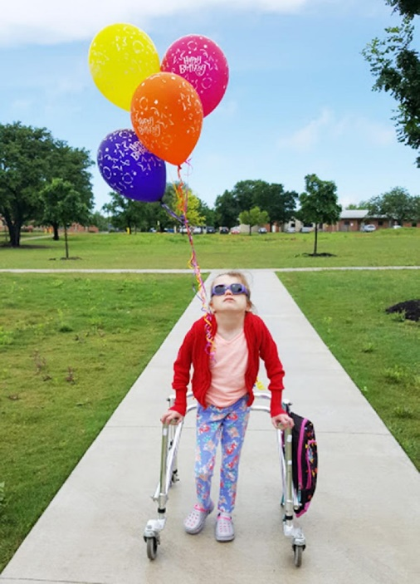
- Audiologist considerations: When noise is removed from an environment in order to optimize the ability to attend to speech, much of the environmental components in the sonic landscape that a student who is deafblind uses to relate to their surroundings also disappear. Considering “noise as information” can be very helpful when deciding which sounds to retain for the user.
- Orientation and mobility consideration: Because hearing amplification changes some sound qualities, the ability identify sounds can be changed when a student uses an assistive listening device. Many times, hearing aids are set to optimize a student’s ability to attend to speech or even speech through a specific source (e.g. an FM System) by eliminating other surrounding sounds. These are typically the sounds a student would use to relate to their environment while traveling or exercising purposeful movement.
Figure 1A young girl with balloons pinned to her jacket uses a walker to navigate a sidewalk.
Many researchers and practitioners in the field of deafblindness emphasize that movement is the underlying skill upon which all other skills are built, but limited vision and hearing in children who are deafblind may inhibit natural curiosity and the motivation to explore and learn from their surroundings. They need environments, learning opportunities, and instruction that encourage and support movement.
Localization, involves determining the location and direction of a sound source in the environment.
- Audiologist considerations: With the elimination or compression of the sound scape the ability to determine where a sound is located and to decipher information about its trajectory can be very challenging. Having bilateral assistance or equalization of intensity to both right and left inputs will allow for great accuracy in auditory perception of the environment.
- Orientation and mobility considerations: Just as stereoscopic vision is required for effective depth perception, having a disparity in hearing between the two sides can making accurately localizing sound very difficult. Determining the presence of an approaching vehicle, locating a dropped object, turning toward a sound source, etc. are all affected.

Auditory Landmarks, Cues, and Clues
Landmarks are persistent, consistent, and unique sounds. Examples might include the sound of a public fountain that runs 24 hours a day and helps an individual to know where they are, or the waves at the shoreline.
Cues are sounds that are not “always” present but give information about where one is. Examples might include the sound of the automatic door at the entrance to the grocery store; it only occurs when you are approaching the door and cues you to the transition from indoor to outdoor, or the sound the elevator makes as it arrives at the level one is standing and often has a unique sonic indicator for the direction of the car, such as one chime for ascending and two chimes for descending.
Clues are sound features that help one to deduce information about their environment, such as hearing a person typing on a computer keyboard or answering a telephone and guessing that you are near a reception desk.

Echolocation
The use of reflected sound to determine the presence and characteristics of features of the environment. This could be hearing a tree (by way of a subtle change in echoes) as one is walking along a sidewalk, or hearing an open corridor in a building to know when to initiate a turn. Passive echolocation is using changes in ambient sound for information about the environment and active echolocation is generating a purposeful noise to be reflected off surfaces in the environment. Purposeful noises could be a sharp tongue click (very effective as the sound returns to the area it was emitted from, specifically the mouth being relatively proximal to the ears), or the tap of the cane tip on the ground. Often young children will use loud vocalizations, hand claps, or foot stomps on the ground to generate echoes. They may not be consciously aware or able to describe what they are doing but have a functional gain in their ability to orient in their environment by doing so.

Collaboration Tool for Environmental Sounds
The following form provides a series of items as a guideline for the collaborative efforts of the audiologist, teacher of deaf and the hard of hearing, and the orientation and mobility specialist. Possible interventions or implications are likely found in the following areas:
Figure 2 Image of a hand holding a pen and completing a form.
- Mic directionality,
- Noise reduction/suppression,
- Ear mold venting,
- Compression,
- Binaural amplification,
- Multiple programs, and
- Potential use of FM+M setting.
Note, a hearing aid does not have to do all of these things all of the time.
You may want to print out these pages (5-10) to aid you in sharing your observations and concerns that impact fitting the student’s hearing aids and other auditory devices.

Student Name:
Date:
COMS:
Teacher of the Deaf and Hard of Hearing:
Audiologist:

Landmarks, Cues, and Clues
(*Note, by definition “landmarks” need to be constant/continuous sounds and therefore may be considered “noise” by amplification.)
Landmarks, Cues, and Clues | Comments
Using sounds from the environment for maintaining orientation (e.g. compressor on the drinking fountain, vending machines, dishwasher, fans, etc.)
Using sounds for clues about the purpose of a public area in commercial setting (e.g. children’s music played in the bookstore near the children’s section, instrument sounds from the band room, etc.)
Using sounds to circumnavigate something (e.g. walking around a fountain in the center of a park)
Monitoring activity sounds indoors in home setting (e.g. from the kitchen area, water running at the sink, flushing toilet, typing on keyboard in the office, parent preparing dinner)
Monitoring activity sounds indoors in commercial settings (e.g. scanner at checkout lines at grocery stores to determine the location of the front of the store and proximity to exits, automatic doors at front of store, cashier at front of Starbucks)

Notes on Student Needs or Concerns

Echolocation
Echolocation | Comments
Using echoes and reflected sound for size of space (passive echolocation would use ambient sound and active echolocation would use a self-generated sounds like tongue clicks or cane taps) for determining size of space such as using sound to determine a big room (e.g. auditorium, gymnasium, or cafeteria) from a smaller room.
Using echoes and reflected sound for orientation and navigation (e.g. using passive echolocation to determine open hallways for turning in route to a classroom using active echolocation to determine the location of a building across a parking lot).

Notes on Student Needs or Concerns

Traffic Considerations for Safety in the Community
Traffic Considerations | Comments
Estimating distance of sound source, fixed source or from moving source
Using the sound emitted from a lane of traffic that is next to the student who is deafblind as they cross the street to make sure their crossing is straight (this is an alignment from the side rather than front to back)
Using sound that emitted from in front or behind as orientation while walking. (e.g. using the beeping accessible pedestrian signal as a target for their destination)
Recognizing sound masking and the dangers that may present by missing an important environmental component (e.g. sound of a plane overpowering the sound of a hybrid car)
Identifying patterns in sounds, (e.g. cars turning at an intersection in various directions)
Distinguishing sources of sounds (e.g. lawnmower, airplane, etc.)
Recognizing sound shadows (e.g. large parked vehicle that blocks the sound of traffic)
Determining distance and direction of sound in traffic settings from all directions simultaneously if possible (e.g. to determining whether an emergency vehicle is approaching or going away from one’s self, determining the proximity and direction of perpendicular traffic or right hand turning cars before stepping into the crosswalk, monitoring for approaching or departing trains at a station platform)
Analyzing distant traffic sounds in residential areas (e.g. detecting cross streets to keep path straight and toward destination, becoming aware of impending street crossings)

Notes on Student Needs or Concerns

Other Skills
Other Skills | Comments
Localizing sounds (e.g. being able to walk to a sound source, for use in retrieving a dropped object)
Monitoring activity sounds outdoors for safety and general awareness of environment (e.g. keeping track of nearby space to be aware of individuals walking up from behind or those approaching from the front)
Understanding when one’s own ability to use sound is impacted by changes within the environment, or within one’s self (for example adverse weather conditions, battery dying in an assistive device, choosing the correct amplification program)

Notes on Student Needs or Concerns

Sounds that may remain inaudible even with the use of amplification
It is important for the team to be aware of sounds that the student may not be able to hear, even with amplification. List these below:

Developing Auditory Skills
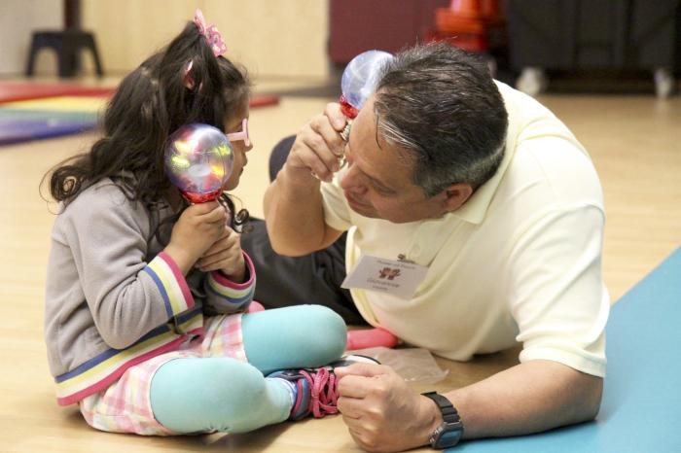
Learning to listen and identify sounds as they relate to sound sources is critical for children who are deafblind. This requires specific instruction for most children to develop listening skills, part of the Expanded Core Curriculum for students who are visually impaired or deafblind.
The team should determine when and how to work on these skills throughout the day since the child will not use his or her hearing only during one activity. This might include one-on-one instruction with a teacher of the deaf and hard of hearing, a speech-language therapist, an intervener, or classroom teacher. It should include “in-the-moment” instruction for everyone who interacts with the child who is deafblind by pointing out specific sounds in the child’s environment and encouraging the child to “listen”. For the orientation and mobility instructor, the activities below may help you get started.
Figure 3 A young child listens to the sound made by a toy while her father listens to his toy.
These activities will be most easily accessed by learners who are utilizing auditory information as their primary sensory input. Having the learner with residual vision use occluders, or simply asking the learner to close their eyes for each activity, will help to highlight the auditory components of the activity.

Distinguishing Sound Sources
There are many online sites that allow “sound effects” to be downloaded. These include footsteps, airplanes, helicopters, emergency vehicles, etc.; you can find just about any sound you would hear in the natural environment. Auditory training might include becoming familiar with what these sounds actually are. Can a learner discern the difference between the rhythmic tapping of a pen tapping the table from the rhythmic pattern of footsteps, or even rain drops into a puddle? These sounds, like visual information, may have to be taught more deliberately, through explicit instruction. You can also use a smart phone to record sounds in the environment that can be saved as mp3 or wav files and shared with the learner so they can practice identifying them.
This strategy is as much for developing auditory skills as it is for evaluating them. Go on a “Sensory Adventure” to observe what the student is able to detect or respond to. This could be done in any setting and you can preplan some sound sources that will either be triggered by you (e.g. a wireless doorbell, noise making toy attached to a motion sensor) or having someone else that can assist with creating the noises while you attend to observing the learner for signs of detecting/alerting to the auditory information and the conditions at that time (i.e. distance from sound source, presence of competing auditory information, etc.). With learners who are able to communicate through formal language, you can “Adventure” into other areas and ask that the learner “sense aloud” and share with you what they are picking up on through the auditory channel. This may include some spontaneous reporting as well as some prompted reporting. You may notice a sound the learner has not mentioned and you may need to use effective questioning techniques to prompt them to report whether they detected the sound(s) you noticed but they had not reported. Specific examples of sound sources/types to look at for “Detection” include sounds like:
- Find a large vehicle (e.g. mini-van, van, large truck, etc.) and have the learner stand on the sidewalk with the parked vehicle immediately between them and the street.
- Ask the learner to listen as cars approach and pass the parked vehicle. Then, ask them to listen to listen to the passing traffic with the parked vehicle nearby but not immediately between them and the street.
- After they are able to discern the difference, have them walk along the side walk as cars are driving in the parallel street and they must walk by the parked vehicle, so that they have the dynamic experience of the sound shadow as they travel.

Recognizing Sound Masking
Working with two radios playing different types of music or sounds, adjust the volume so that both are approximately at equal levels.
- Ask the learner to sit in a location/position that allows them to hear both radios equally. Have the learner increase the volume of one of the radios until the sound overpowers the other radio’s sound.
Bring folding chairs to an intersection and have the learner listen to idling vehicles at the intersection.
- Ask the learner to continue trying to listen for the idling cars as another lane receives the green ball/light from the signal and their surge is heard.
- Ask if the learner was still able to hear the idling cars or if the sound of the surge washed out/masked the quieter sound of the idling vehicles.

Localizing Sounds
Beginning in a quiet room or an area where you have some control over the environment to ensure that you will be able to keep your sound cue as the only auditory input, keep a constant sound source playing sound as you walk around the learner in a larger circle.
- Have the learner point alternately to you or the sound source and continue to track you as you circumnavigate around them, going completely around in both directions.
- Place a sound source a good distance from the learner and have them point to where they hear the sound source and then ask them to walk to it.

Delineation of Roles Related to Safe and Independent Travel for the Student with Deafblindness
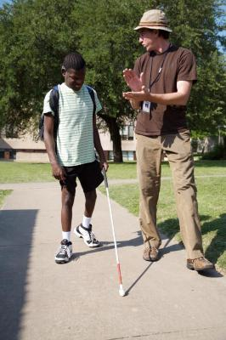
Due to the complexity of needs of students who are deafblind continuous input from a core group is often needed to guide daily programming. The function of the core team is to review, refine, and direct on-going educational programming and may include those who daily and weekly interact with the student (e.g. parent, intervener, classroom teacher, teacher of students with deafblindness, teacher of students with visual impairments). The core team should meet regularly (weekly, bi-weekly, monthly or quarterly) based on the student’s needs. An extended team may meet with the core team when expertise is needed in specialized therapy areas (e.g. PT, OT, O&M). (Listed alphabetically, not in order of importance)

Audiologist
- Providing training with personal amplification device of the student to Teacher of Deaf and the Hard of Hearing (TDHH)
Figure 4 n orientation and mobility instructor works with a young man who is deafblind and using a travel cane.
- Provide audiological evaluation and results of evaluation to Educational Team
- Collaborate with Orientation and Mobility Specialist (COMS), Teacher of Deaf and the Hard of Hearing (TDHH), Family, and other Educational Team Members
- Selecting and programming appropriate personal amplification device and FM System/Classroom Amplification Device
- Verification of proper working order of personal amplification device and FM System/Classroom Amplification Device
- Providing training with personal amplification device of the student to other members of the Educational Team
- Maintaining the personal amplification device to the extent necessary as the student develops independence

Certified Orientation and Mobility Specialist (COMS):
- Evaluate and instruct in use of audition for environmental sounds in functional setting
- Communicate specific uses of environmental sounds to Audiologist, TDHH, and other members of Educational Team
- Receive training on student’s use of their personal amplification device from Teacher of the Deaf and Hard of Hearing (TDHH)
- Write goals and objectives related to safe and independent travel skills
- Provide written recommendations for adaptations related to safe and independent travel
- Request attendance at the audiological evaluation if permitted

Intervener
- Act as a communication bridge for the Orientation and Mobility Specialist and the student
- Provide input to the team on the student’s preferences, dislikes, behaviors and orientation and mobility needs
- Work with the student, family, and entire educational team to develop IEP goals and objectives
- Reinforce orientation and mobility skills and concepts through activities and routines
- Promote the student’s independence to ensure their needs (including safety) are met

Families
- Complete assessment inventories that contributed to evaluation data
- Working with the student on developing maintenance skills for the personal amplification device and FM System/Classroom Amplification Device
- Practice skills introduced during instruction with TDHH and COMS
- Provide information regarding student’s use of audition and ability to access environmental sounds in varied environments, positive aspects as well as challenges observed and expressed

Teacher of Deaf and the Hard of Hearing (TDHH)
- Support the COMS and the audiologist’s collaboration to insure that the student’s personal amplification device includes programs to access environmental sounds targeted in the O&M evaluation.
- Provides the Certified Orientation and Mobility Specialist with training and practice in the use and maintenance of the student’s personal amplification device.
- TDHH actively works with the COMS
  - To assess the child’s current ability to detect, discriminate and utilize the environmental sounds targeted for Orientation and Mobility skill development.
  - To write accommodations and strategies for the IEP to support the use of environmental sounds in Orientation and Mobility activities across all settings for developing independence in the school, home, and community
  - To write IEP objectives for auditory training for the sounds targeted in the Orientation and Mobility evaluation
  - Involve parents and other team members in implementing strategies for developing skills and concepts identified in goals and objectives related to environmental sounds and purposeful movement/independent travel

Teacher of Students with Deafblindness (TDB)
- Educate Team on deafblindness and building auditory skills
- Does not replace Teacher of the Deaf and Hard of Hearing (TDHH), unless they are dual certified as Teacher of the Deaf and Hard of Hearing (TDHH) and Teacher of Students with Visually Impairments (TVI)
- Provide information regarding the impact of the child’s etiology on learning style and behavior
- Evaluate the impact of the child’s vision loss and hearing loss on the acquisition and use of preferred mode of communication
- Participates in all IEP or IFSP meetings to insure appropriate programming and services specific to deafblindness
- Participates in developing Behavior Intervention Plans
- Provide the families with information regarding services for students with deafblindness from state agencies
- Supports the intervener

Teacher of Students with Visually Impairments (TVI)
- Educate Team on impact of visual impairment on and developing visual skills for students with remaining vision
- Does not replace Teacher of the Deaf and Hard of Hearing (TDHH), unless they are dual certified as Teacher of the Deaf and Hard of Hearing (TDHH) and Teacher of Students with Visually Impairments (TVI)
- Evaluate the impact of the child’s vision loss on the acquisition and use of preferred mode of communication and learning media

Tip Sheet for the Teacher of the Deaf and Hard of Hearing

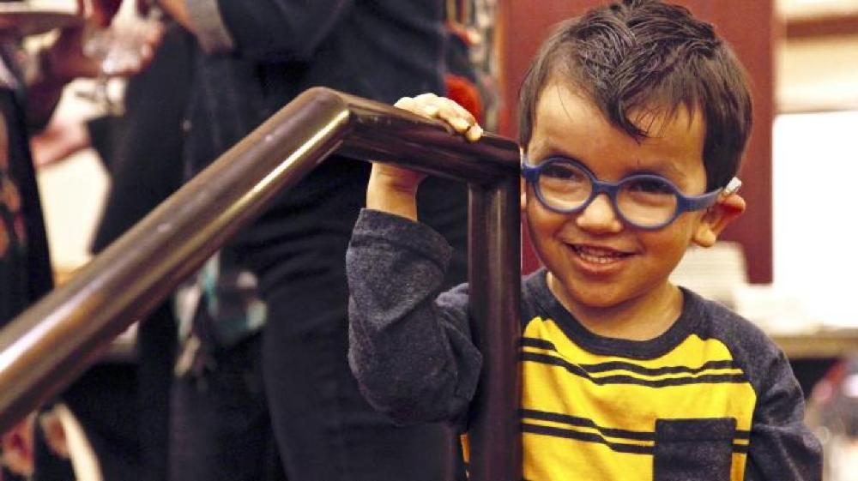
Access to Information
Figure 5 A young toddler who is deafblind grasps the handrail as he prepares to descend the stairs.
For a student who is deafblind, the combined effects of the vision and hearing loss create a barrier that significantly impedes the ability to gather information from the environment. This can lead to a lack of access to incidental learning and delayed or fragmented concept development. Students cannot learn what they do not detect, and they may be unaware of what they are missing. Similarly, developing auditory skills is critical in order for these students to be safe in and able to navigate and learn from their environment. Determining the best approach for maximizing audition for students who are deafblind will require a team approach and possibly even looking at these skills from a new perspective. Access to information is a primary issue for all students who are deafblind, and should be addressed in each IEP. The effects of deafblindness should be taken into account in assessments, evaluations and delivery of all related services provided to the student.

Assessments
Skill, patience and teamwork are all required to meaningfully assess students who are deafblind. Two areas with which the teacher of the deaf and hard of hearing is very familiar show this concept clearly. The audiological report not only includes a description of the implications of hearing loss in a variety of settings with or without amplification, but also addresses the student’s vision loss in the following areas:
- Ability to communicate during O&M instruction and during interaction with others during travel in various types of lighting conditions (twilight, with artificial light, bright sunlight, in glare) determine:
  - Appropriate distance and placement for receptive fingerspelling and signing.
  - Appropriate pacing for receptive fingerspelling and signing,
  - Appropriate access to tactile signing and fingerspelling, hand tracking, and co-active signing if necessary, and/or
  - Appropriate distance for speechreading.
- Ability to identify speaker or sound source at both near and distance in all types of lighting and in varying sound environments which is critical to identifying landmarks, cues, and signals and evaluating traffic noise;
- Ability to localize sound source with or without amplification for orientation and mobility at both near and distance in all types of lighting; and
- Ability to see a referent under discussion at both near and distance in all types of lighting.
Note: To properly assess this the TDHH should collaborate with the TVI and/or COMS. You may want to reference the Assessment of Deafblind Access to Manual Language Systems (ADAMLS).

Teaming
Due to the complexity of needs of students who are deafblind, continuous input from a core group is often needed to guide daily programming. The function of the core team is to review, refine, and direct on-going educational programming and may include those who interact with the student (e.g. parent, intervener, classroom teacher, teacher of students who are deafblind, teacher of students with visual impairment, teacher of the deaf and hard of hearing) daily and weekly. The core team should meet regularly (weekly, bi-weekly, monthly or quarterly) based on the student’s needs. An extended team may meet with the core team when expertise is needed in specialized therapy areas (e.g. PT, OT, O&M).
In regards to orientation and mobility instruction, all staff should be guided in communicating with the COMS. It is the COMS who will determine priority skills and share strategies for things like sighted guide, travel within the classroom and outside the classroom, the use of trailing, pre-cane and travel canes, how to help the student tune-in to landmarks, cues and clues, sound identification and localization. They can also train the team on the use of proper techniques to support independent travel.

Communication
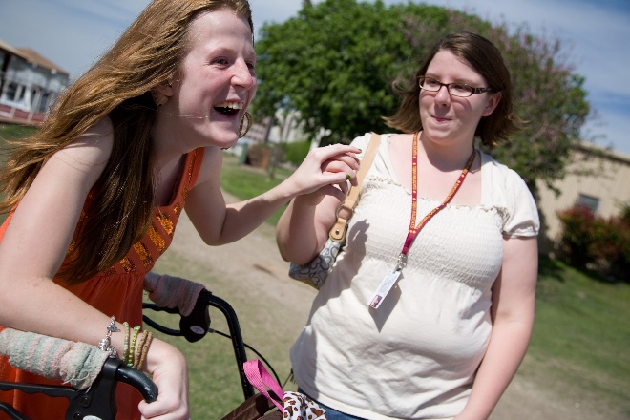
A combined vision and hearing loss can profoundly impact the development of both receptive and expressive communication. A lack of informal and/or formal communication creates a barrier affecting all areas of learning. Many students who are deafblind encounter a lack of access to engagement with potential communication partners without support from someone (e.g. intervener, interpreter, DB teacher) who can bridge the divide between the student’s unique communication system and the communication systems of sighted-hearing speakers. Without this support the student is cut off from accessing both instruction and conversational interactions that are key to learning.
Figure 6 Figure 6 A young woman and her intervener communicate using tactile sign as they navigate the sidewalks during travel.
During O&M instruction, the student is likely to require the support of an intervener or other qualified communication partner if the COMS is not trained in the child's individual communication system. Even if the COMS is able to communicate, it is important that they understand how to check that communication devices and amplification are working properly. The student may also need some type of communication system for engaging with the public while traveling in the community. This might take the form of a print booklet with braille or tactile symbols attached or the use of assistive technology.

Etiology
There are a number of syndromes that result in both a vision and hearing loss and may have bearing on the best educational approaches to use with the student. For example, the concept development of a student with CHARGE Syndrome may be affected by their experiences of numerous early hospitalizations. They may also experience problems with balance. A student with Usher Syndrome, may appear to see very well until it is dark or as they move from dark to light environments. They may also have balance problems.
Understanding and helping to educate the team on any impact of the child's etiology that may impact travel is important.

Behavior
For students who are deafblind, issues of challenging behavior are usually closely tied to sensory access and communication. Behavior is often the result of coping with situations that seem confusing or threatening due to lack of information available from others or from the environment. It can also be the result of frustration from lack of access to partners skilled in responding to the student’s methods of communication. This can create barriers in recognition, trust, and bonding between students and caregivers which can have an impact on behavior. Additionally, behaviors may result from the student’s need to stimulate or regulate sensory input, or they may be in response to pain associated with medical conditions like glaucoma or ear infections.
It is important to understand the root cause of any distress that may be labeled as "behavioral challenges" and develop strategies to address them. Travel outside of very familiar environments or if the child does not feel safe may trigger some of this type of distress. Helping the team know how to communicate with the child when they are distressed and how to prepare the child for potentially stressful travel situations is important.

Social Issues
Deafblindness can impact the ability to form relationships and respond to interactions with others in typical ways. For example, a lack of environmental information makes it difficult to identify people, locate them, know what they are doing, or understand what they want. Many ordinary interactions may seem threatening, negative, or confusing to the student. In turn, the student’s need to gather information by close viewing and/or touch can offend others. It is not unusual to see withdrawal and problems with bonding. It is important to consider that social problems for a student who is deafblind are often the result of an on-going lack of essential information. The psychological impact of changes in vision and hearing experienced by a student who is deafblind may need to be addressed in the IEP.
Because travel in the community is an important part of orientation and mobility instruction, the team may need to provide specific instruction related to situations like meeting strangers, appropriate personal space, and stranger danger. Not all children will become skilled enough to travel independently, but all of them will interact with the public throughout their lives. Addressing critical personal interaction skills is very important for all students who are deafblind.

Orientation and Mobility (O&M)
Deafblindness affects the ability of students to know where they are, and how to go from place to place. Certified orientation and mobility specialists (COMS) will find that working with this population may require some changes in instructional approaches. Students who are deafblind receive less information from the environment which may impact their motivation to explore. Deafblindness affects the identification and use of sound cues. Students need more orientation to environments, and strategies to gather information about their surroundings.
As the TDHH, if you are working with a student who is not receiving orientation and mobility instruction, you may need to talk to your team about requesting assessment in this area. Additionally, you may recognize situations that are causing problems for the student that others are not aware might be occurring. You need to make note of this and share it with the team as part of informal assessment.

Transition Planning
The need for experientially-based vocational assessment and instruction in real-world environments is heightened when sensory issues affect access to environmental information and practical experience. The ability to initiate and sustain meaningful leisure activities is impacted by the capacity to learn through modeling and gather environmental cues. Being an effective self-advocate about communication and access to information is essential for success in higher education, employment, and other community settings. Additionally, referrals to community services designed for people who are deafblind (e.g. community intervener, support service provider, interpreter, specialized residential & vocational support) lead to better adult outcomes.
One major support for many young people who are deafblind, is helping them to find community after they leave school. As the TDHH you may have access to various deaf-related supports and resources that others on the team do not have such as adult deaf clubs and organizations, special Medicaid waiver programs for deafblind, and likely employment resources.

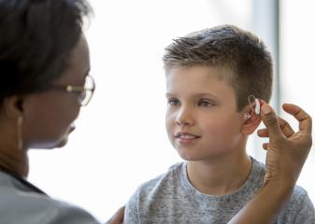
Sample Letter to the Audiologist
When the student goes to an audiologist, who may not be aware of the special challenges of providing appropriate assessment and amplification for a student who is deafblind, the orientation and mobility specialist may want to draft a letter to send with the child and his parents or the teacher of the deaf and hard of hearing. Below is a sample letter you may want to use to guide you.
Figure 7 An audiologist places a hearing aid in the ear of a child.

Letter to the Audiologist
I am a Certified Orientation and Mobility Specialist (COMS) with SCHOOL NAME Independent School District. I am doing an evaluation of STUDENT’S NAME who is deaflblind. An important part of my evaluation addresses sounds that are necessary for safe travel in the community. I would like an opportunity to discuss the following with you:

  - Any adjustments to the assistive listening device to allow the student to access environmental sounds;
  - The ability of this student to localize sounds;
  - The physical limits to accessing and safely using environmental sounds (e.g. traffic) when traveling independently;
  - The ramifications of amplification for travel as a pedestrian in a variety of settings (e.g. residential, commercial, light business) and using public transportation; and
  - The ability of this student to access auditory information from accessibility apps (e.g. talking GPS) on a smartphone and attending to traffic sounds simultaneously if possible.
Thank you very much for your assistance in understanding the unique needs of this student related to accessing environmental sounds to develop and enhance their ability to travel safely and independently.
Please feel free to phone me at PHONE NUMBER or email me at EMAIL ADDRESS.

Texas School for the Blind & Visually Impaired
Outreach Programs
Texas Deafblind Outreach

This project is supported by the U. S. Department of Education, Office of Special Education Programs (OSEP). Opinions expressed herein are those of the authors and do not necessarily represent the position of the U. S. Department of Education.

