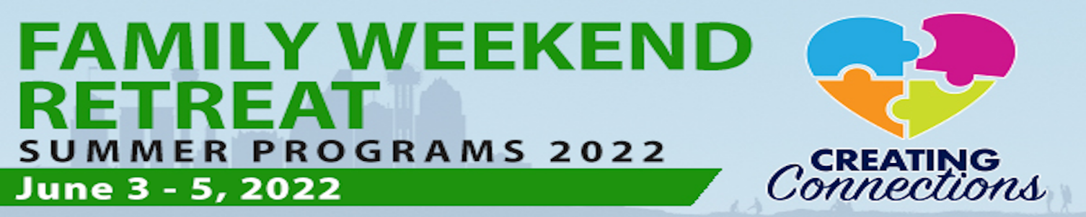
Figure 1: Family Weekend Retreat Creating Connections 2022 logo
A Glimpse into Our Lives: Families of Children and Young Adults Who are Deaf Plus
Our Favorite Connections & Resources

Family Organizations:
  - American Society for Deaf Children: https://deafchildren.org/
- ASL Moms (TSD group)
- ATTACh (organization focused on child trauma and attachment issues): https://attach.org/
- Deaf-Blind Multihandicapped Association of Texas (DBMAT): dbmat-tx.org
- National Family Association for Deaf-Blind: nfadb.org
- Texas Chargers, Inc.: texaschargers.org
  - Texas Hands & Voices: txhv.org
- Guide By Your Side
- Advocacy Support & Training (ASTRA) Program
- Texas Parent to Parent: txp2p.org

Family Developed Websites:
- Navigate Life Texas: navigatelifetexas.org
- Parent Companion: First 5 Years: parentcompanion.org
- Texas Project First: texasprojectfirst.org

Education Resources:
- Texas School for the Deaf, Statewide Outreach Center: texasdeafed.org
- Texas School for the Blind & Visually Impaired Outreach (aka Texas Deafblind Project): tsbvi.edu; txdeafblindproject.org
- Texas Sensory Support Network: txssn.org
- National Center on Deaf-Blindness: nationaldb.org
- Special Education Information Center: spedtex.org

Insurance & Financial Help for Children with Disabilities: https://www.navigatelifetexas.org/en/insurance-financial-help
- Supplemental Security Income (SSI) & Social Security Disability Insurance
- Community First Choice Program: https://www.hhs.texas.gov/services/health/medicaid-chip/programs/community-first-choice
- Texas Medicaid Waiver Programs: navigatelifetexas.org/en/insurance-financial-help/texas-medicaid-waiver-programs-for-children-with-disabilities

Medical
- Medical Home: https://www.navigatelifetexas.org/en/videos/video/medical-home
- Got Transition®: https://www.gottransition.org/
- Medical Education (MEd.) Program: https://www.txp2p.org/services/medical-education-program-med

