Texas School for the Blind and Visually Impaired
Outreach Programs
www.tsbvi.edu | 512-454-8631 | 1100 W. 45th St. | Austin, TX 78756

Guidance for Planning Behavior Intervention for
Children and Young Adults who are Deafblind
or have Visual and Multiple Impairments

Developed by Matt Schultz, Deafblind Education Consultant
Kate Moss Hurst, Deafblind Education Consultant
Lynne McAlister, VI Education Consultant
Deanna Peterson, Deafblind Education Consultant
Texas School for the Blind & Visually Impaired Outreach Programs

From the Authors

Children who are deafblind or have visual and multiple impairments pose unique challenges to the educators who work with them because of their unique learning style resulting from reduced or missing access to information through vision and hearing. This is especially true if the child has limited communication skills, has always had limited vision and/or hearing, and experiences additional disabilities or medical issues. Frequently the way these children behave in response to this lack of information is interpreted as intentional “bad behavior”. In fact, these troublesome behaviors are a natural response to stress caused by feelings of fear and confusion. Science is only beginning to show us what impact stress has on all human development and functioning. We want to ask educators working with these children to reframe their thinking about behavior these children may exhibit and see a child in distress rather than a child who is willfully “acting out”.

In this booklet, we hope to provide information for educators and others that will help in developing proactive strategies in programming to reduce the amount of stress the child might experience. We believe that appropriate programming does reduce stress and helps to develop children who are eager to learn and participate with others. The first portion of this booklet discusses key components of programming for students who are deafblind or visually and multiply impaired that supports the child in becoming more resilient and competent interacting with others and the world. This book addresses those students with the most severe challenges, though most of these strategies are also beneficial for students who are more advanced communicators with fewer additional challenges.

We also know that sometimes a child comes to a program already in a highly distressed state. Even programming that utilizes these proactive strategies isn’t always enough to meet their needs. Our second goal, therefore, is to also provide responsive strategies for the most fragile children by guiding teams in the development of behavior intervention plans specifically for children who are deafblind or have visual and multiple impairments. The second portion of the booklet contains forms to use in the process of developing an appropriate plan for intervention when behavioral challenges occur.

These forms contain a series of questions the team may want to consider in evaluating current programming for the child. It also contains questions to guide the team in developing a full profile of various factors that might contribute to the child’s overall functioning. We also include forms to use for collecting data on specific problematic behaviors and finalizing the Behavior Intervention Plan (BIP). Your team may choose to use only part of these forms since your district may have specific documents they prefer to use. More important than the form is considering all of these factors whenever you are developing Behavior Intervention Plans for a child who is deafblind or has visual and multiple impairments.

We would like to think our colleagues at Texas School for the Blind & Visually Impaired for their help in developing this document. We would especially like to thank David Wiley, Mari Hubig and Theresa Johnson for their contributions to this document. We would also like to thank the parents, colleagues and our Outreach team members for their support in reviewing and editing this document. We are deeply indebted to the students who are deafblind or visually and multiply impaired who have taught us so much about how to provide appropriate supports that help a child develop resiliency to overcome the stressors they endure.

Contents

Narrative
Positive Behavioral Interventions and Supports 0
Research 1
Impact on Social/Emotional Development and Learning 4
Proactive Strategies to Avoid Distress 7
Responsive Strategies to Reduce Distress 17
Resources and References 22

Forms
About these Forms 28
Step 1 - Clarify Information about Concerns 29
Step 2 – Additional Information Related to a Child with deafblindness or visual and multiple impairments 31
Step 3 - Basic Health Considerations and Other Issues 32
Step 4 – Review the current program 33
Step 5 – List of Intervention and Supports – Tier 2 42
Step 6 - Taking Data on Observable Behaviors 43
Step 7 – Tier 3 Responsive Intervention and Supports 45
Step 8 – List of Intervention and Supports – Tier 3 51
Step 8 - Behavior Intervention Plan 54
Step 9 - Take Data on Observable Behaviors 55

Guidance for Planning Behavior Intervention

for Children and Young Adults who are Deafblind

or have Visual and Multiple Impairments

Positive Behavioral Interventions and Supports
Children who are deafblind or visually and multiply impaired face many challenges in receiving a Free and Appropriate Public Education (FAPE), and challenging “behaviors” often rises to the top of the list. Under the IDEA, the primary vehicle for providing FAPE is through an appropriately developed individualized education program (IEP) based on the individual needs of the child. 34 CFR §§300.17 and 300.320-300.324. In the case of a child whose behavior impedes his or her learning or that of others, the IEP Team must consider – and, when necessary to provide FAPE, include in the IEP – the use of positive behavioral interventions and supports, and other strategies, to address that behavior. 34 CFR §§300.324(a)(2)(i) and (b)(2); and 300.320(a)(4).
The National Technical Assistance Center on Positive Behavioral Interventions and Supports (PBIS) is funded by the U.S. Department of Education, Office of Special Education Programs and Office of Elementary and Secondary Education. Their purpose is to improve the capacity of SEAs, LEAs, and schools to establish, scale-up, and sustain the PBIS framework. They describe three tiers of positive behavioral support that are considered in addressing behavioral concerns. It is important to remember these tiers refer to levels of support students receive, not to students themselves.
Tier 1: Universal Prevention (All Students)
Tier 1 supports serve as the foundation for behavior and academics. Schools provide these universal supports to all students. For most students, the core program gives them what they need to be successful and to prevent future problems.
Tier 2: Targeted Prevention (Some Students)
This level of support focuses on improving specific skill deficits students have. Schools often provide Tier 2 supports to groups of students with similar targeted needs. Providing support to a group of students provides more opportunities for practice and feedback while keeping the intervention maximally efficient. Students may need some assessment to identify whether they need this level of support and which skills to address. Tier 2 supports help students develop the skills they need to benefit core programs at the school.
Tier 3: Intensive, Individualized Prevention (Few Students)
Tier 3 supports are the most intensive supports the school offers. These supports require are the most resource intensive due to the individualized approach of developing and carrying out interventions. At this level, schools typically rely on formal assessments to determine a student’s need and to develop an individualized support plan. Student plans often include goals related to both academics as well as behavior support.
Tiered Framework (https://www.pbis.org/pbis/tiered-framework)
Tier 1 supports might be, for example, the school’s code of conduct. Tier 2 might include supports such as participation in a social skills class or the inclusion of specific behavioral and instructional strategies. Tier 3 supports are very intensive and individualized and might include the development of a form Behavior Intervention Plan.
Children and young adults who are congenially deafblind or have visual and multiple impairments may engage in behaviors that are expressions of emotional distress. These expressions, often displayed in rejections, refusals, or aggressive and self-injurious behavior, can:
- create a barrier to forming close personal relationships;
- hinder social development as well as the development of a healthy state of emotional well-being;
- create challenges for active participation in educational programs.
As a result, finding ways to minimize these distressed expressions needs to be the focus of inquiry, problem solving, and teaching when planning for positive behavior intervention and support for children who are deafblind or have visual and multiple impairments. At the same time, supporting the child’s healthy social, emotional, and communicative development are critical elements of any interventions.
Many of these children who are deafblind or visually and multiply impaired require extensive and unique interventions and supports that would be considered Tier 2 and Tier 3 levels as described by The National Technical Assistance Center on Positive Behavioral Interventions and Supports. What are these interventions and supports? How does an educational team determine which specific interventions and supports are needed for a child?
In trying to address these issues, let’s first take a look at current research and what it tells us about the underlying reasons behind any child’s expressions of emotional distress.

Research

Social and Emotional Health Impact Brain Development
Emotional well-being and social competence provide a strong foundation for emerging cognitive abilities, and together they are the bricks and mortar that comprise the foundation of human development.
The Science of Early Childhood Development – Harvard University Center on the Developing Child
Here are some quotes from The Science of Early Childhood Development, Center on the Developing Child - Harvard University:
Brains are built over time, from the bottom up. The basic architecture of the brain is constructed through an ongoing process that begins before birth and continues into adulthood. Early experiences affect the quality of that architecture by establishing either a sturdy or a fragile foundation for all of the learning, health and behavior that follow.
Emotional well-being and social competence provide a strong foundation for emerging cognitive abilities, and together they are the bricks and mortar that comprise the foundation of human development.
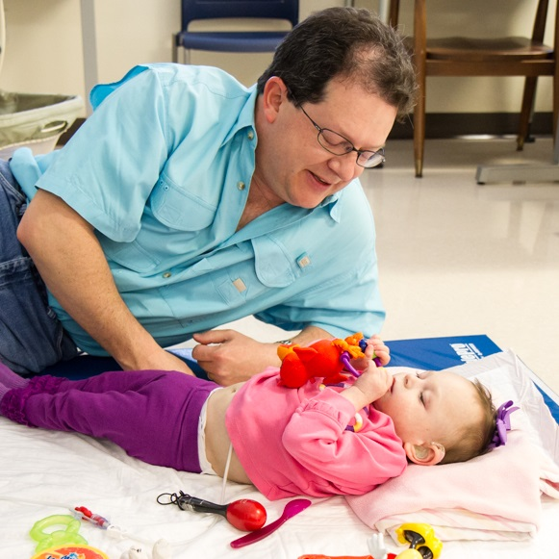
Toxic stress damages developing brain architecture, which can lead to life-long problems in learning, behavior, and physical and mental health.
Figure 1A father interacts with his Deafblind daughter as she lies on the floor.
Scientists now know a major ingredient in this developmental process is the “serve and return” relationship between children and their parents and other caregivers in the family or community. In the absence of such responses—or if the responses are unreliable or inappropriate—the brain’s architecture does not form as expected, which can lead to disparities in learning and behavior.
Experiencing significant adversity early in life can set up our body’s systems to be more susceptible to stress throughout life, with long-term negative consequences for physical and emotional health, educational achievement, economic success, social relationships, and overall well-being.
Young children experience their world as an environment of relationships, and these relationships affect virtually all aspects of their development – intellectual, social, emotional, physical, behavioral, and moral. The quality and stability of a child’s human relationships in the early years, lay the foundation for a wide range of later developmental outcomes that really matter – self-confidence and sound mental health, motivation to learn, achievement in school and later in life, the ability to control aggressive impulses and resolve conflicts in nonviolent ways, knowing the difference between right and wrong, having the capacity to develop and sustain casual friendships and intimate relationships.
The Science of Early Childhood Development Center on the Developing Child
Harvard University
Stated simply, relationships are the “active ingredients” of the environment’s influence on healthy human development. They incorporate the qualities that best promote competence and well-being – individualized responsiveness, mutual action-and-interaction, and an emotional connection to another human being, be it a parent, peer, grandparent, aunt, uncle, neighbor, teacher, coach, or any other person who has an important impact on the child’s early development. Relationships engage children in the human community in ways that help them define who they are, what they can become, and how and why they are important to other people.

Children who are born Deafblind or with visual and multiple impairments may experience reduced quality and frequency of these critical interactions as a result of their sensory losses…Other factors such as multiple hospitalizations, illness, or extremely limited access to the people, things and events around them, all serve to further isolate the child and produce stress.
In the words of the distinguished developmental psychologist Urie Bronfenbrenner: …”in order to develop normally, a child requires progressively more complex joint activity with one or more adults who have an irrational emotional relationship with the child. Somebody’s got to be crazy about that kid. That’s number one - first, last, and always.” (Young Children Develop in an Environment of Relationships – National Scientific Council on the Development Child, 2004. page 1.
What science is now showing us is that brain development is greatly impacted by the quality of the adult-child interactions from the earliest age. Children who are born with these significant sensory challenges may experience reduced quality and frequency of these critical interactions as a result. The child's “serves” (conversational initiations) may not be recognized or affirmed as such. In such instances, the child and his communication partners are at risk for entering into conversational patterns dominated by the adult. That is, conversations characterized by an abundance of adult directives as opposed to a back and forth exchange of thoughts and ideas. Parents may begin to lose confidence in their ability to connect or have these serve and return exchanges when their child does not hear them, may not make eye contact, or is in an extremely stressed state much of the time. Other factors such as multiple hospitalizations, illness, or extremely limited access to the people, things, and events around them, all serve to further isolate the child and produce stress.
The Center for the Developing Child at Harvard University proposes a set of “design principles” they recommend for improving outcomes for children and families undergoing extreme stress. These principles are:
- Support responsive relationships for children and adults.
- Strengthen core life skills.
- Reduce sources of stress in the lives of children and families.
Core Principles of Development Can Help Us Redesign Policy and Practice,
Center on the Developing Child, Harvard University

These core principles may also serve as a basis for improving, not only the social and emotional development of the child with sensory loss and additional challenges, but also the child’s overall development in communication and cognitive skills.

Theory of Self-Determination
Over the course of 30 years of research, Richard Ryan and Edward L. Deci at the University of Rochester have developed a theory of human motivation, personality development, and well-being. The theory focuses on volitional or self-determined behavior and the social and cultural conditions that promote it. Ryan and Deci’s work states that healthy human functioning (regardless of where the individual is in their development) has a set of three innate psychological needs that, when met, allow for optimal function and growth.
- Competence- the need to control outcomes in their environment and experience mastery. The need to feel successful.
- Autonomy- the need to be causal agents of one's own life and act in harmony with one's integrated self. The need to feel independent.
- Relatedness- the universal need to interact, be connected to, and experience caring for others. The need to feel connected.
When people experience feelings of connectedness, success, and independence, they are experiencing the opposite of emotional distress. They feel safe and secure. They feel calm. Their bodies and brains are open to the type of exploration and inquiry that is necessary for learning and growth. (Schultz, 2019)
When people experience feelings of connectedness, success, and independence they are experiencing the opposite of emotional distress. They feel safe and secure. They feel calm. Their bodies and brains are open to the type of exploration and inquiry that is necessary for learning and growth.

Impact on Social/Emotional Development and Learning
To effectively understand the underlying causes of behavior in a child who is deafblind or has visual and multiple impairments, it is necessary to understand the impact of the child’s individual sensory impairments in forming responsive relationships, learning basic life skills, and creating extreme stress in the child’s life.

Isolation
Depending on the degree of vision and hearing loss experienced by the deafblind child, he or she is “essentially isolated unless they are in close proximity, or in direct physical contact, with another person.” (Miles and Riggio, 1999). This is also true for the child with visual and multiple impairments in many cases. The requirement of proximity to another person, necessary to experiencing these responsive relationships, is one of the first challenges a child who is deafblind faces. For any parent or caregiver to be in this type of proximity twenty-four a day, seven days a week is beyond challenging; it is impossible. Despite best efforts, most individuals who are deafblind spend a great part of their day isolated from the people and events occurring around them. This is no less true for many children with visual and multiple impairments, especially if their physical or health challenges limit mobility and basic movement. Access to the world when vision and hearing are limited means, in effect, that much of the child’s waking hours are spent in isolation where they are disconnected from the activities, materials, and people that make up the world.

Access to information
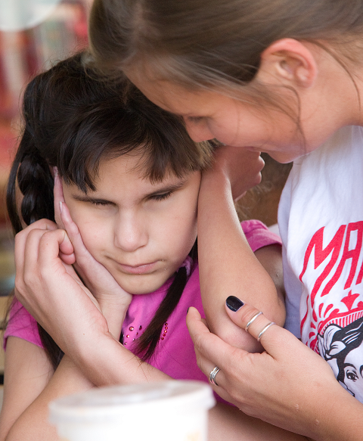
The world, for most deafblind or visually and multiply impaired children, is very narrow and may exist for some children at the boundary of their own bodies. Their understanding of how the world works, basic foundational concepts, is greatly impacted. As a result, often the “core life skills” needed to live fulfilling lives are often not fully developed.
Figure 2 An adult using touch to connect with her student who is Deafblind.
Adults who work with these children need strategies (specific to the child) which can help the child have this access. Most adults, including special education staff or even vision or hearing teachers, may not have these strategies when they encounter a child with these significant challenges. They do not know how to teach a child when learning cannot successfully take place through the visual or auditory methods typically used in school settings. They may also not know how, nor have resources to provide supports such as interveners, interpreters, individual support staff, tactile materials, etc. which would allow the child to have the level of access to the information other children have.

Limited number and variety of experiences, especially social experiences
Most of these children have extreme delays in the development of foundational concepts and communication skills because of limited access to information about the world around them. This limited access further impacts their ability to form meaningful and supportive relationships in all environments. The child who is deafblind or visually and multiply impaired may have very limited and unusual topics they want to share with others. They are like a ballet dancer at an auto mechanics convention who wants to talk about Swan Lake. No one is interested in talking about what they know and enjoy.
“I do not remember when I first realized that I was different from other people; but I knew it before my teacher came to me. I had noticed that my mother and my friends did not use signs as I did when they wanted anything done, but talked with their mouths. Sometimes I stood between two persons who were conversing and touched their lips. I could not understand, and was vexed. I moved my lips and gesticulated frantically without result. This made me so angry at times that I kicked and screamed until I was exhausted.”
The Story of My Life (1902) by Helen Keller, Chapter 2.

When other individuals encounter these children, they may be reluctant to try to interact, or they may approach the interaction with the child in a way that causes the child to respond negatively. These failures to make a connection may cause both the child and those wanting to interact with the child to retreat from each other.
For the most part, children who are deafblind or has visual and multiple impairments are very limited in the number and variety of experiences they have. This is not the fault of the child or the people around them necessarily. Taking in information about what is happening when vision and hearing are limited or nonexistent is a slow process and always somewhat limited, even with extensive supports.

Illness and multiple hospitalizations
For many children who are deafblind or have visual and multiple impairments, illness and hospitalizations are frequent and lifelong occurrences. Experiences related to poor health and frequent hospitalizations would be stressful for anyone, but when combined with limited ability to know or anticipate what is happening to you, it can be a very traumatic experience.
Things are done to you when you are sick to help you get well, but many of these things are very painful or confusing. Doctors and hospital staff, while very knowledgeable about treating the illness, have little or no knowledge of how to support the child with sensory loss while providing this treatment. For the child who frequently experiences these situations year after year, a toxic level of stress becomes part of everyday life.

Behavior is communication and an expression of internal distress
In looking for ways to help children who are deafblind or have visual and multiple impairments feel safe, more connected, successful, and independent, we first need to understand that all behavior is communication. When these children engage in distressed behavior they are doing so because they do not have a better way to communicate their complex feelings. What we see as observable behavior may be attempts to communicate about internal feelings; feelings of happiness, excitement and joy as well as feelings of frustration, disappointment or helplessness.
Though we may not always consider this, students may feel deep loss and need to grieve the passing of a family member, a parent who is absent from the home or the decrease of vision or hearing. Just like we feel anxious about our next encounter with an individual when we have behaved poorly, a student may also feel regret or low self-esteem about previous negative interactions with others.

Proactive Strategies to Avoid Distress (Tier 2)
Strategies for addressing behaviors that do not resolve underlying issues of communication, security, and control, may work in the short-term, but these solutions usually result in the return of the behavior or in replacement behaviors that may be even more troubling. Lasting change comes from providing more information, teaching new skills, modifying activities or environments, and finding ways to give the child more choices and influence. All of this should occur within responsive environments and relationships. Children who are deafblind or visually and multiply impaired, generally need unique Tier 2 strategies to address the impact of sensory loss, limited mobility, and ongoing stress.
The most important consideration is not what to do in the moment in response to distressed behavior, but what to do on a continuous basis to help prevent it from occurring. Preventing distressed behavior is best achieved through use of consistent strategies that create an environment in which the child who is deafblind or has visual and multiple impairments feels safe, successful, independent, and connected.

Fostering Feelings of Safety
Making a plan to help the child feel safe and secure in the classroom environment is the first and most important element in supporting the child’s social and emotional growth. Healthy social and emotional development is the foundation of all learning and should not be overlooked. Creating a positive and responsive relationship between teacher and child is central to the child’s sense of connection, but it takes time, attention, and effort. The following strategies can help a child build a stronger sense of connection to educational staff and others.

Spend time with the child and observe their movements
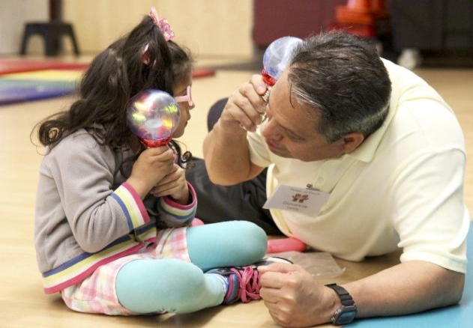
Take time to be with the child and get to know him or her as an individual. Observe the often subtle cues that can provide insight into personal interests and thoughts. Where are the child’s hands? Where is his gaze? What sounds does she enjoy listening to? Is he interested in vibration, a specific texture, or physical properties of an object? What types of objects, movements, sights, sounds, smells, or people naturally draw the child’s attention? Create an “appetite/aversion” list making notes about the things that elicit a child’s positive responses in one column and those that elicit negative responses in another. This will allow you to design instruction to include highly motivating materials and activities and reduce the occurrence of aversive materials and activities.
Figure 3 A father imitates the actions of his daughter.

Be in close proximity with the child
Some children may need an adult or peers to be in direct physical contact through most activities, perhaps sitting on the floor with your leg touching their leg or your arms touching their arms. Others may not, at least initially. It is important not to force any physical contact, and it may take quite a while for a child with sensory loss and other significant challenges to trust you. Get as close as the child will allow, and overtime, as trust builds, chances are the child with allow more direct physical contact. Initially some children may “come in close and then “run away”. They may have to summon their courage to connect, and then take a little break from you. This is about self-regulation. Don’t chase after them unless they are in danger. Give them time to step away and return on their own.

Follow the child’s lead

Make time daily to offer objects or actions of interest to the child, and draw the child’s attention to you and the world around him. These objects or actions of interest can be actual objects, music from a device or musical instrument, interesting vocalizations, touch, and/or movements of your body. Observe what the child does with your offering, and follow the child’s lead by imitating him or her. Depending on the child’s ability to access your responses through vision or hearing, do this in near proximity to the child’s body to ensure the child is aware of what you are doing. By following the child’s lead, you let the child know that you are aware of what he is doing and that you can do that, too.
“Meanwhile the desire to express myself grew. The few signs I used became less and less adequate, and my failures to make myself understood were invariably followed by outbursts of passion. I felt as if invisible hands were holding me, and I made frantic efforts to free myself.…I generally broke down in tears and physical exhaustion. If my mother happened to be near I crept into her arms, too miserable even to remember the cause of the tempest. After a while the need of some means of communication became so urgent that these outbursts occurred daily, sometimes hourly.”
The Story of My Life (1902) by Helen Keller, Chapter 3.

Mark your entries and exits from the child’s world with greeting and parting rituals
If you are unaware of someone entering into your space or departing from your space, the world is a bit scary. Think about things and people coming at you from out of nowhere; it would distress you as well. When entering into an interaction with a child, it is good to establish greeting and parting rituals. These can be as simple as sharing a ring on your hand, a particular touch such as a “high five”, or waving hello and good-bye. This lets the child know that you are there, ready to engage with him, or that you have to leave for a time.

Acknowledge the child’s emotions and share yours
The root of all language development is in our emotional experiences. Think of a newborn who cries when in distress or discomfort. When the parent responds with soothing caresses or gentle pats, the child knows that his or her distress is recognized and someone is offering help. The same is true when the child experiences joy or wonder at some experience. Mirroring his or her emotions helps nourish your connection and helps the child learn about emotions and self-regulation.
As the child gains communication skills, naming and talking about emotions and feelings can help reduce the child’s anxiety and stress. Parents and others need to help children regulate their emotions until they learn how to regulate them on their own. When comforting the child, you might sign or say the word for the feeling they seem to exhibit such as “angry”, “frightened”, “sad”, and “excited”.

Establish turn-taking routines
Observe the child and wait for her to make a movement or sound. After you imitate the child’s action or sound, then pause for a moment. Repeat this process over and over. First, the child takes a turn, and then the adult responds by imitating the child. This serve and return response is the basis for all conversation. The child will begin to recognize that you are interested in what she is doing and thinking. This creates a connection between you and the child.

Fostering Feeling of Success
In order for children to feel successful, they must have the confidence to act and interact with the world. This means they have to figure out how basic things in the world work; this knowledge is the foundation for all future learning. This includes the ability to differentiate object properties (texture, temperature, weight, size, shape, etc.), recognize specific movement, and to begin to form concepts related to abstract qualities like time and gravity. Children also have to be able to communicate with others about what they know.

Design activities based on the child’s interests
All humans tend to be more successful when engaging in activities that interest them. It provides motivation that keeps us engaged in experimenting, exploring, and figuring out how something works, what it can do, and what typical purpose it serves. For all children, finding things that motivate and interest them is critical to instruction. This can be somewhat more challenging with children who have very limited or unusual interests which is often the case with children who are deafblind or visually and multiply impaired, especially if they have additional disabilities.
Figure 4 A young man wiping bowling balls with a rag.
It is necessary that we take time to observe what the child does when left to play alone with a variety of materials and when interacting with trusted others. Dr. Lilli Nielsen guides us to look at these behaviors to help identify the child’s “Pathways to Learning” or available sensory channels for learning. Dr. Jan van Dijk tells us to view these behaviors and areas of interest as potential “topics” for adult-child conversations.
Does the child reach for or otherwise explore certain objects and avoid others? How does he explore objects or engage others – patting with hands, rubbing feet, licking with his tongue? Do certain sounds, colors, movements seem to engage her? What does he do with his body – rock, play with his feet, slap his hands together? All of these things can give you clues to whom and what might interest your child. Once identified, these components can be incorporated into learning environments, activities, and routines. Conversely, things, actions, or people that evoke a negative response or disinterest can be avoided as much as possible.

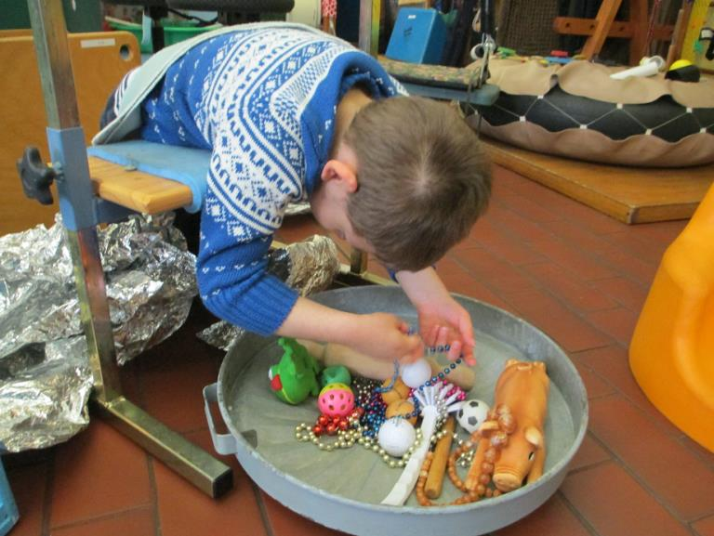
Provide many opportunities for the child to explore and experiment with objects and materials
Figure 5 A young boy explores various objects.
All humans learn critical foundational skills and concepts through our own independent exploration and experimentation with objects in our environments. We learn about textures, temperature, weight, shape, size, density, flexibility, function and so forth. Children with sensory loss and other significant disabilities may be limited in their awareness of the things around them and/or lack the mobility to access them. We need to bring the world to the child and allow time for the child to find out on his own what each thing is like and what it can do. Dr. Lilli Nielsen’s Active Learning approach and the Curriculum for Multi-sensory-impaired Children from Victoria School, Birmingham, England are two resources that can guide educators to in providing these opportunities for foundational concept development.

Utilize an appropriate calendar system that stays in a defined location
For all humans, stress is reduced when we know what things will happen and when they will happen each day. This is especially true for our children who are deafblind or have visual and multiple impairments. It is important that each child have a personal calendar system. The type of calendar will depend on the child’s understanding of time and his level of receptive and expressive communication. We recommend Robbie Blaha’s book, Calendars for Children with Multiple Impairments Including Deafblindness to learn more about calendar systems and how to determine the appropriate type of calendar for a specific child.
Any child may “meltdown” when faced with something they don’t understand or expect. Adult support to help reassure them during these times is critical. But we must be careful to balance that support with plenty of opportunities for the child to try things on his own to find his own successes and learn to cope with failures.
Keep the child’s calendar in a specified location, so the child can find it when he or she needs reassurance about what is coming next or when a preferred activity will occur. The child may also need to use the calendar to help communicate his or her excitement or concerns about an event or person in their future or past. Sharing about an anticipated visit to see a beloved grandpa or a dreaded visit to the doctor can help relieve stress and anxiety about these events. This also increases the child’s confidence in his or her ability to have some choice and control over what is happening.
Calendar conversations provide a wonderful opportunity for back and forth or “serve and return” interactions. The structure and focus that calendar conversations can create, ensures a child’s subtle conversational initiations are recognized, understood, and affirmed in ways that are clear to both conversation partners.

Provide the support needed so he or she learns to cope with successes and failures
It is important to recognize the level of independence and support the child may need at any given point in time. We want our children to experience successes in all they undertake, but we also must help them cope when they fail to do something.
Resilience results from a dynamic interaction between internal predispositions and external experiences. Children who do well in the face of significant disadvantage typically exhibit both an intrinsic resistance to adversity and strong relationships with the important adults in their family and community. Indeed, it is the interaction between biology and environment that builds the capacities to cope with adversity and overcome threats to healthy development.
Resilience, therefore, is the result of a combination of protective factors—and neither individual characteristics nor social environments alone are likely to generate sufficiently positive outcomes for children who experience prolonged periods of toxic stress.
Supportive Relationships and Active Skill-Building Strengthen the Foundations of Resilience
National Scientific Council on the Developing Child
A child who is deafblind or has visual and multiple impairments often lacks basic skills needed to make choices and participate independently in his world. When presented with a challenge, it is as if an inner voice begins to say, “I can’t do this,” and the child becomes distressed. This may cause the child to exhibit behaviors that further prevent learning and participation in the activity. When we provide just enough support, we allow the child opportunities to build skills while not feeling unable or unsuccessful. Over time with adequate and consistent support, resiliency grows, eventually allowing the child to be more successful with less direct support. Through a saturation of successful skill building opportunities, the child’s internal voice shifts to “I CAN do this.” Success coming from one’s own actions changes the child’s biology by building internal capacity to meet and overcome challenges; that is to become more resilient.

Respond to distress immediately by increasing support and redirecting
Any child may “meltdown” when faced with something they don’t understand or don’t expect. Adult support to help reassure them during these times is critical. We must also be careful to balance that support with plenty of opportunities for the child to try things on her own to find her own successes and learn to cope with failures. We also want the child to let us share the experience with him. So initially, we place little or no demands on the child and keep the unexpected at a minimum. As the child gains more confidence in his or her own abilities, we pull back our support slightly. We introduce novelty into the day or the activity “by the teaspoonful,” increasing challenges gradually as the child shows readiness to complete a step or action on his or her own.
Students in distress sometimes respond by rejecting things, people, or activities; displaying aggression to self or others; or being unable to move forward with activities. These situations are most successfully defused by increasing support rather than calling attention to the behavior observed. Defusing a stressful situation and getting the student back on track to be successful might employ modifications such as:
- changing pace;
- reducing demands or expectations;
- providing more information;
- increasing physical assistance;
- introducing calming strategies.
Calling attention, negative or positive, to the behavior often reinforces the behavior and increases the likelihood it will happen again. Focusing on the distressed behavior diverts attention from the activity, makes it more difficult to re-engage, or causes the behavior to escalate.

Fostering Feelings of Independence
As children move through the stages of development, they begin to acquire skills that provide a sense of mastery and help them to feel and act with an increased level of independence. The emergence of an increased level of confidence and the demonstration of new skills can replace or eliminate distressed behavior.

As much as possible, “do with, not for” when engaging with a child
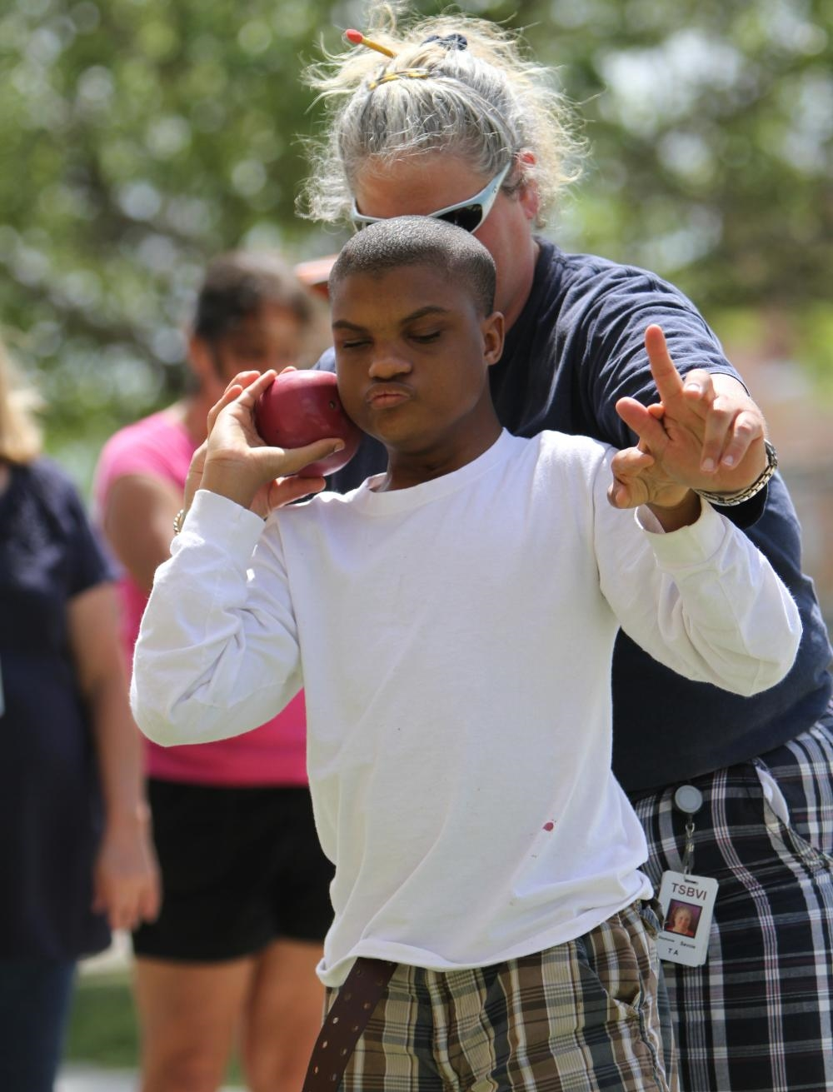
Children with sensory loss and other significant disabilities are at great risk for developing passivity and learned helplessness. Though it may take longer to acquire independent living skills, part of the problem is the lack of opportunities to practice skills sufficiently. Without practice, the ability to do simple tasks efficiently results in the child giving up and/or the adult taking over the task.
Figure 6 A young man throws a shot put with his teacher.
The child needs to be engaged in practicing skills in many environments all day long. This means that some of the time the child should be engaged in independent play or activity, and some of the time the adult interaction should be included. In either case, the adult needs to let the child attempt to do as much as he or she feels confident in doing without interference from the adult.
Educators have the critical task of being able to judge just how much support is needed at any point in time and provide only what is necessary. This involves providing plenty of “wait” time for the child to initiate an action before intervening and following the child’s lead when offering support.
If a child is just learning to reach and grasp an object or navigate around his classroom, he has to have many opportunities throughout the day to practice these skills. This might mean that instruction focuses intensely on a limited number of skills initially. For that reason, teams need to have knowledge about typical developmental milestones to be able to develop appropriate programming.
Initially the child may not choose to interact with the adult. Then the adult will offer activity or objects to the child and let the child chose to accept it or reject it without comment. (Nielsen, 2003)
As the child begins to trust the adult, then imitating the actions of the child become important. This is a way of acknowledging the child’s experience and sharing your interest. This also imparts meaning by letting the child know that you share the knowledge or skill they are demonstrating. This leads, in time, to the child becoming willing to imitate the adult, which is a critical step in the development of communication and conversation skills. (Nielsen, 2003 and Miles & Riggio, 1999)
Some children are at a developmental level where they need to “share the work” or only take the steps they feel confident in doing within an activity. Just like many of us, our children may become shy when asked to perform for others or in unfamiliar environments. It may be easier to sing with someone than to sing alone. A child might need to have a trusted adult beside her to feel confident when selling homemade breakfast tacos. As activities become more familiar and the child gains confidence, increased expectations and “consequences” arising from their behavior may come into play. (Nielsen, 2003)

Designate specific areas of the classroom to store belongings and to do regular activities
We all feel more confident when we are in familiar environments. When a child has poor or absent vision and hearing, this becomes even more important. Establish the child’s place in a classroom by designating a place where possessions from home are stored, specific activities take place, and where favorite materials can be located. Make sure the child travels to these locations to complete the activity and, when possible, to gather materials.
This will help him feel more confident to explore the environment on his own and to be more self-determined in his choices about activities and interactions. Initially the child may need materials and activities to be nearby, especially if movement and travel is difficult. Extend the distances as the child gains skills and confidence in navigating his or her space.

Support the development of the child’s expressive forms of communication
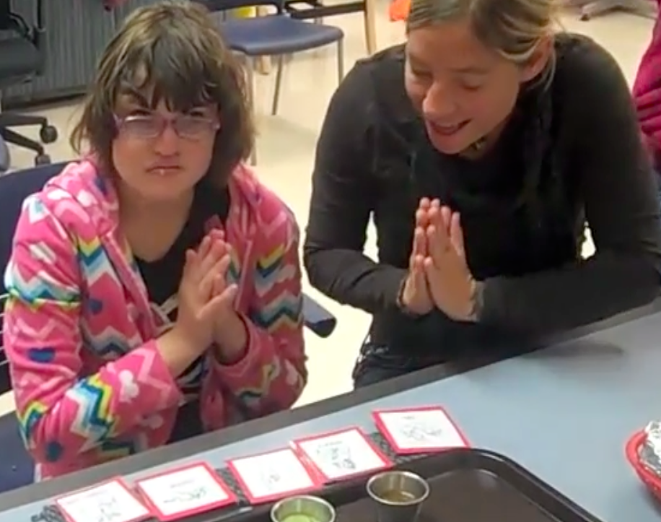
Babies hear and understand a substantial number of spoken words before they actually begin to speak in meaningful words or phrases. Children who are deafblind or have visual and multiple impairments are no different, except that they may have greatly reduced exposure to language or understanding of concepts because of their sensory deficit(s). They may also have little or no modeling of expressive communication forms that they can use, since use of speech and print aren’t in their skill set.
Figure 7 An intervener supports a young Deafblind girl in communicating during an activity routine.
From the earliest ages, these children need significant support to develop their expressive communication skills. This begins by tuning into and providing consistent vocabulary for whatever forms their communication takes, beginning with the basic behaviors they exhibit. Parents do this with typically developing babies naturally. They watch what the baby does with his or her body and guess at what might be going on. “Oh, you are hungry!” “I think that doggy scared you!” “You like bouncing!”
You may not know how to provide similar support to a child who is deafblind or visually and multiply impaired if you are not familiar with alternative communication forms. Begin to respond by using simple concrete forms of communication (e.g., sharing a real object or mimicking the child’s actions) that let the early communicator know he has been heard. Respond as best you can to what you think is wanted or needed by providing the object or action. (e.g., give him the bottle, take him away from the scary dog, or express happiness and excitement with your movements.)
If you know more abstract forms of communication, for example, a sign, gesture, or symbol, they can also be paired with what you do. The most important thing, however, is to recognize the movement, behavior, or action as an attempt to express a need or thought and respond without monopolizing the conversation (remember, serve and return). Watch and wait to see if the child has something else to communicate. Conversations without formal language sometimes require more time.
As the child begins to be more adept with various expressive communication forms, the need to pay attention, respond, and then give the child an opportunity to comment is critical. Take the time necessary for the child to share what he is thinking or feeling and supply language that may be missing in his vocabulary. Give names especially to emotions.

As much as possible, allow the child to make choices about activities and the daily schedule
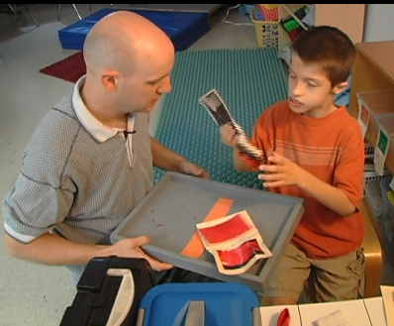
A mark of independence for humans is the ability to make choices about activities and events that occur in our lives. When we don’t feel we have choices, this can become a source of stress. School settings, out of necessity, are often extremely regimented. Meals, recess, physical education in the gym, music in the music room, and therapies must be scheduled to keep things running smoothly for the majority of the children and staff. However, when a child is in distress, they may not be able to follow the schedule easily on any given day.
Figure 8 A teacher offers a choice-making board during calendar time for the student to select a preferred activity.
It is important to understand that many of these children are delayed in their emotional and social development, despite having many skills that are near normal. They may lack the ability to self-regulate. They may lack the ability to sit in a seat, work with attention for more than a few minutes, and may easily become frustrated when asked to comply with instructions that they lack the confidence to complete. Think of a cranky two-year old in a grocery cart while mom is shopping…we know how challenging this activity can be for both parent and child.
When a distressed child is asked to complete a series of non-preferred activities or tasks, they may become resistant. If pressed to continue the activity, their resistance can escalate especially if it continues for any length of time. Conversely, if a child is enjoying a particular activity, leaving that activity before they are ready may cause problems. Providing choices as much as possible can help the child cope.
While structure and routine help provide security to the child, flexibility with scheduling and activities can provide relief to a stressed child. As much as possible, set up systems, such as calendars and choice boards, to allow the child to choose activities and the sequence of activities throughout the day. If the activity is not preferred, let the child schedule a preferred activity immediately following it. If a non-preferred task or activity must be completed, allow the child to complete it with minimal participation and for a shorter period of time before moving on to something new.
On the other hand, when the child wants to continue a preferred activity a little longer, allow that to happen while setting some specific limits. You may need to use tactile markers or other communication supports to track time or number of turns that will continue. This helps the child to emotionally prepare for the end of the activity and may make it easier to transition from the preferred activity.
Most importantly, if the child is having a really bad day or is in great distress, don’t force the child to complete activities that will only cause behaviors to escalate. Allow the child the opportunity to reject an activity for the moment and let the child do something else. You can always come back to the original activity later.

Fostering Feelings of Connectedness
Humans are social beings; the drive to connect with other humans is “hardwired” into our brains as a driving survival tactic. However, being deafblind or having other disabling conditions such as autism can impede the ability to make those connections unless systematically addressed as part of all instruction. Communication, especially the ability to share our stories, is a key factor in building connectedness and developing good mental health.

Develop a communication system that allows for reciprocal communicative interaction
Communication is the critical to building trust and relationships, both of which are instrumental in creating confident and engaged children. Whether the child uses behavioral responses, gestures, signals, signs, print, pictures or speech to communicate, communication must be reciprocal.
That means that we do as much (or more) listening as we do talking. Consider everything the child does or shows interest in doing as a possible topic of communication. Let him or her know you are interested in what they are trying to share by affirming the topic. For example, at one level you might do this by imitating the child’s movements or at another level by following them as they pull you to a favorite area or activity then reflect on what usually happens there. (Van Dijk & Nelson, 2001)
Some children with more sophisticated communication systems may be able to tell you about something they did or something they are anxious about doing with spoken words, signs or pictures. Just remember, during these interactions, do not dominate the conversation. Take a turn, make it brief, and then wait for what the child has to share next. By following the child’s conversational lead, you are affirming their communication form as well as their sense of agency. When you listen to them, they feel listened to. Overtime, they will become more confident communicators, assured that people are interested in what they have to say. (Van Dijk & Nelson 2001)

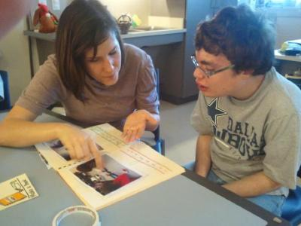
Acknowledge and record meaningful experiences in books or story boxes to share with others
Figure 9 A student and his teacher share an experience story.
Since the beginning of time, for all human beings, our ability to tell and re-tell our experiences helps us to cope and make sense of what we experience. Creating experience stories is a very important way to help a child who is deafblind or visually and multiply impaired share their interests and feelings with others.
Children may start with a collection of objects kept in a box or bag that are associated with an activity or experience. These objects can be shared and explored with an adult or peer and the appropriate language can be added. As the child’s communication system develops, creating books or even journals about events that are important or impactful helps the child to reflect on the experience and possibly anticipate it, if it is a recurring event. This allows the child to work out and share feelings about the event. It may help them discuss their ability to handle or be successful in a situation with the people who share the event with them.

Build connections through membership in a community
As much as possible, the child who are deafblind or have visual and multiple impairments needs to feel a part of a community. At first, that community may be only the family. Later, it may extend to specific adults and peers that have daily contact with him.
Part of belonging to a community is feeling that you contribute and are valued. Children with sensory loss and other significant disabilities, just like their peers, find self-fulfillment through contributing and sharing responsibilities. This can be as simple as putting dirty dishes and utensils in a container to wash, or it can be as involved as making a product and selling it. Being connected comes from taking your part in a turn-taking routine or interaction.
Any child, no matter the severity of their disabilities, can contribute in some way. This helps to build a strong self-identity. Community helps us all know that we are valued as well as supported. Work with your child to plan a party, build a garden, or simply sing and dance in a group.

Responsive Strategies to Reduce Distress (Tier 3)
Sometimes, even when we deliver a quality program that promotes social and emotional development, problems may occur. The child may begin to demonstrate increased distressed behavior (e.g., anxiety, withdrawal, self-injurious behavior, aggression). If these behaviors become heightened or continued after implementing a program of proactive strategies, there are additional strategies that can foster feelings of safety, however, planning is required. Strategies that help to support a child exhibiting heightened or continued distress include the follow suggestions.

Fostering Feelings of Safety

Minimize contact with people, places, or things that trigger behavior problems
“Sometimes, it is true, a sense of isolation enfolds me like a cold mist as I sit alone and wait at life’s shut gate. Beyond there is light, and music, and sweet companionship; but I may not enter. Fate, silent, pitiless, bars the way…
Silence sits immense upon my soul. Then comes hope with a smile and whispers, ‘There is joy is self-forgetfulness.’ So I try to make the light in others’ eyes my sun, the music in others’ ears my symphony, the smile on others’ lips my happiness.”
- The Story of My Life (1902) by Helen Keller, Chapter 22
If a certain situation routinely leads to problems, do not continue to expose the child to that situation. For example, if a child becomes distressed every time she travels down a busy hallway, develop a plan to avoid the hallway during school-wide transition times. This may require changing travel routes or class schedules to ensure that the child can transition without becoming distressed.

Alter materials or the environment to discourage less appropriate behaviors
Make it harder for the child to engage in these behaviors by using safe materials or by physically blocking potential problem areas. For example, strategies such as using metal instead of glass cups that don’t break when thrown, placing an extra chair between an aggressive child and classmates, or arranging the furniture so it is difficult to run out the door, can prevent recurring problems.

Alter activity schedules to reduce stress.
When faced with a difficult or dreaded activity such as preparing our income taxes, most adults will take short breaks or “treat” themselves to mini-rewards. Some of us even avoid the task by employing tax accountants to do the work for us. Children who are deafblind or have visual and multiple impairments can also benefit from similar strategies.
Alternate difficult activities with enjoyable ones. Other activities may need to be entirely changed or completely stopped. It may be necessary to provide periods in the day so the child can rest or have less simulation. Including the child with sensory loss and other significant disabilities in all of his or her peer’s activities may not be important if it causes problems for the child. Consider using these times for building other skills or engaging in one-on-one activities with a trusted adult.

Be aware of signs that indicate potential problems and make necessary modifications
Children usually show some subtle signs that they are becoming frustrated or distressed about something they did or something they are anxious about doing before more significant expressions of distress occurs. It is important that people interacting with the child can recognize precursor behaviors and take data on these behaviors to fully understand their meaning. Staff must remain flexible and make necessary modifications or adjustments in schedules or activities that prevent escalation. Helping the child retain a feeling of safety, security, and success is always the most important outcome of any interaction, routine, or lesson.

Make sure there is structure, routine and predictability throughout the child’s school day
When a child is unsure of what is about to happen, where it will be happening, and with whom it will happen, he usually will not act with purpose and independence for any other reason than to get out of the task or environment. Make sure the child has a highly predictable structure to the day and that it is reflected in his calendar system.
Create highly structured routines with clear beginning, middle, and end steps so the child is able to anticipate each step in the process. The ability to anticipate is required for the child to take an independent initiative within the structured activity. To reduce stress, it is also necessary to keep the location, sequence of steps, materials, partners and their actions, and the expected role of the child as consistent as possible.

Fostering Feelings of Success

Increase the level of support so the child doesn’t become frustrated by difficult activities
During some activities, or when the child is going through a difficult time, extra help may be required to make sure the child is successful. Some examples of increased support include:
- shorten the wait time during activates in which the child’s stress level begins to escalate;
- decrease or increase the pace of the activity to help the child be able to complete the final step in the routine;
- accept any attempt the child makes to partially participate in the activity rather than insisting on perfection or full participation;
- allow short breaks so the child can attempt to self-regulate before continuing the activity;
- perform any step(s) of the activity the child seems unable or unwilling to complete after allowing plenty of time for the child to try that step.

Deliver information to the child in a form that is accessible, understandable, and accurate
When someone is in distress, we do not want to use complicated or complex language as we intervene. Use consistent strategies with communication form(s) that provide the best visual and auditory access and that are based on the child’s ability to understand the world. In many cases, this means a careful simplification of the event. Keep directions and instruction as simple as possible when the child is showing signs of distress.
Some children require combinations of tangible forms of communications paired with sign or speech, especially if they are in great distress. For example, a child who is distressed by having to complete an activity that is somewhat aversive such as brushing teeth, might benefit from visiting his activity calendar and holding the object or tactile symbol for a favorite activity and being told “next”.
If the child becomes upset when a favorite activity is delayed, introducing the concept of “wait” and “later” can be helpful. Teaching the child that “wait” is not the same as “no” helps the child to hang in there just a bit longer for the reward of the preferred activity or object.
It is also important that everyone interacting with the student uses the same language, especially in times of distress. The team can benefit from taking time to develop a list of targeted vocabulary to describe activities and situations the child will experience throughout the day.
It is crucial for the Teacher of Students with Visual Impairments, the Teacher of the Deaf and Hard of Hearing, the classroom teacher and the Speech and Language Pathologist to collaborate in designing and implementing an individualized communication and calendar system.

Fostering Feelings of Independence

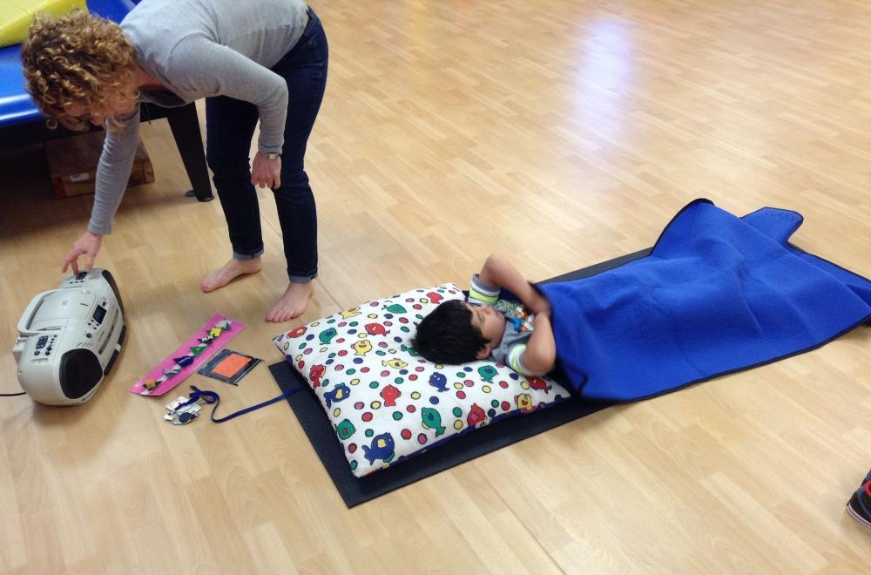
Teach coping skills and provide opportunities to practice these skills in structured and safe environments
Figure 10 A teacher helps her student to calm by lying on a yoga mat and listening to music for a short time.
Coping skills are developed over time; none of us is born with the ability to cope easily with what the world brings us. Children who are deafblind or has visual and multiple impairments may be significantly delayed in their ability to self-regulate or cope with stress.
Beyond simply soothing a child, we can use strategies that help teach self-calming techniques. This could include strategies like taking deep breaths, taking a time out, or using positive physical activity (e.g., yoga, taking a walk, rocking in a rocking chair) to return to a calmer state when she becomes upset or frightened.
Learning how to name and manage one’s own emotional state in a positive way ensures greater independence in the world. Help give a name to the child’s distressed and calm states. For example, you might say, “you are angry” or “now you are calm”.

Provide direct Instruction in social skills
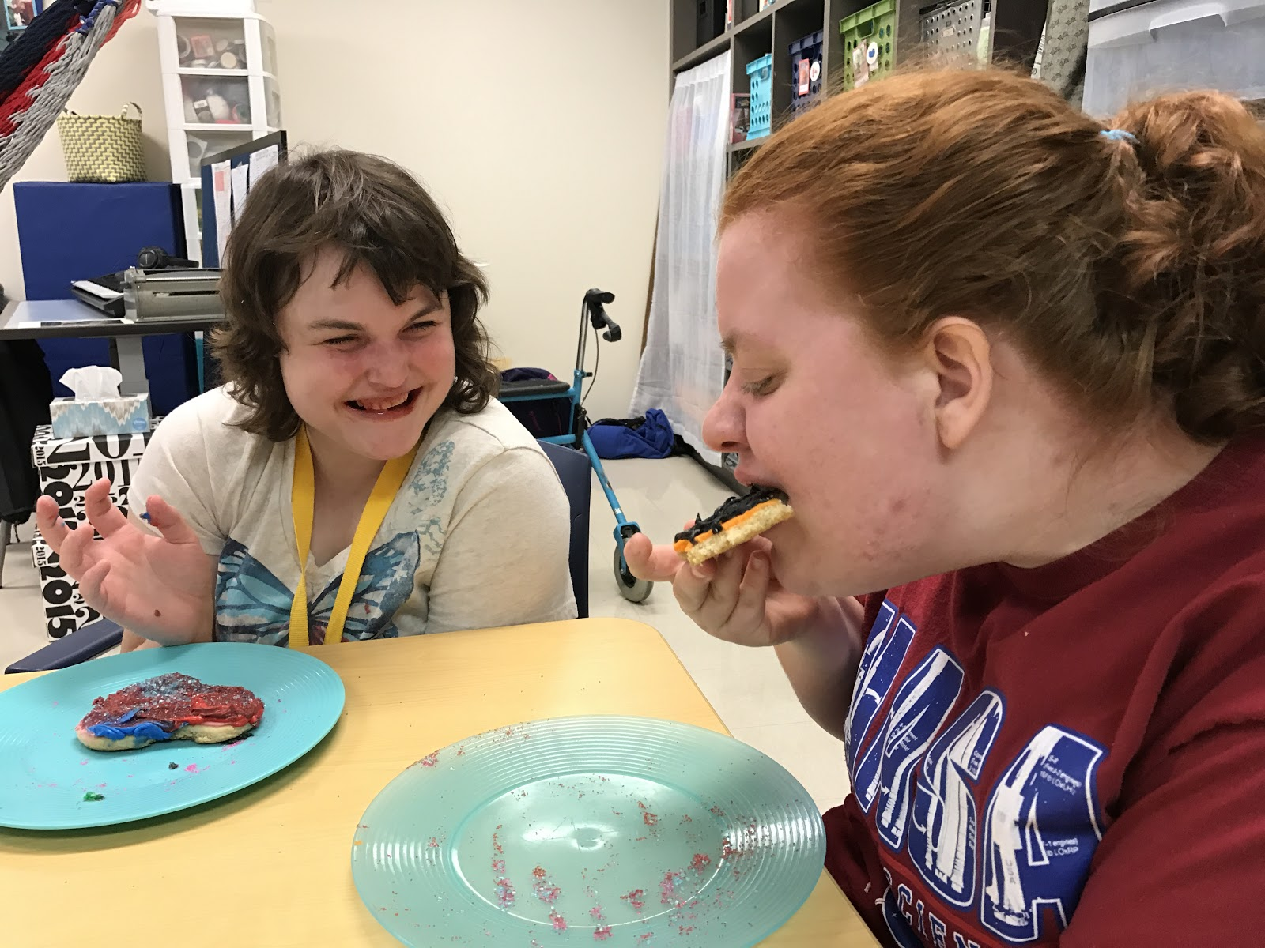
We learn most of our social skills incidentally by simply observing the behaviors of others. Children who are deafblind or visually and multiply impaired miss out on this information or, at best, have an incomplete understanding of “the rules” that govern our behavior. When you think about it, our social rules can be very confusing. It is okay to remove your clothing in the bathroom, but not okay to remove them in the kitchen. It is okay to sniff perfume on a wrist, but it is not okay to sniff someone’s armpit. When you first meet a colleague at the beginning of the day at work, it is appropriate to introduce yourself or say hello, but you don’t need to do it every time you interact with them during the rest of the day.
Figure 11 A teacher helps her student to calm by lying on a yoga mat and listening to music for a short time.
All children who are visually impaired struggle to some degree with learning the ins and outs of social interactions. That is why social skills are a required element in instruction for these individuals as part of the Expanded Core Curriculum (Dignan, 2016).
Build elements of social skills instruction into activities throughout the day, both in planned and incidental learning situations. Practice greetings and departure rituals, learn about how to properly ask for things or reject them. Take time to ensure that instruction occurs about appropriate touch, modesty, and personal safety. Help the child learn to join into a conversation or introduce a topic for conversation with others.
The way we touch a person who is Deafblind is very, very important. For a significant proportion of the people who are Deafblind, touch is their primary (and most reliable) way of receiving information, and they will be sensitive to how they are touched in ways that most of us who can see and hear may only begin to imagine. A touch for a person who is Deafblind can convey emotion, intention, goodwill or lack of it, haste or ease, approval or disapproval. We need to know when we touch what it is we wish to communicate. We need to learn how to make our hands and bodies convey our intentions.
- Remarkable Conversations, 1999. Barbara Miles and Marianne Riggio

Demonstrate the emotional state you want the child to achieve
One fascinating scientific discovery in recent years is the existence of “mirror neurons.” Mirror neurons represent a distinctive class of neurons that discharge both when an individual executes a motor act and when he observes another individual performing the same or a similar motor act.” (Acharya and Shukla, 2012)
For a child who is deafblind or has visual and multiple impairments, observing someone might include not only visual and auditory information, but also tactual information. Many adults who are deafblind report that they gain information about the emotional state of others through touch. Dr. Jan van Dijk first used his “resonance” approach in working with congenitally deafblind individuals because he felt “we can mirror each other's actions and emotions”. (van Dijk, Role of the Emotional Brain, no date provided) When working with a child who is deafblind or has visual and multiple impairments, we need to demonstrate the emotional state we want from the child.
We have to be mindful during our direct instruction. This allows us to slow our pace, use relaxed, expressive touch, and not become distracted by events and people around us. Keep the focus on the child. Observe his emotional state as it may manifest in body tension, vocalizations, and movement. Model a calm demeanor as you work with the child and don’t let your emotions escalate as the child’s escalate. (Miles & Riggio, 1999 and MacFarland, 2000)

Fostering Feelings of Connectedness

Encourage participation through the projection of a positive affect
By modeling your interest and enjoyment in the activity, you are encouraging the child to take interest. If a child has limited or no vision, this means we need to convey actions and our emotions through tactile means. In fact, we already do this to some degree whether we know it or not. For example, you may need to express excitement through somewhat exaggerated movements.
If the child has hearing, using various voices that convey curiosity, excitement, or enjoyment can be used to encourage the child’s participation. If the child has some vision and the ability to recognize facial expression, make sure the child sees interest and enthusiasm on your face and in your movements.

Additional Considerations

Medical issues
Medical issues can play a big role in distressed behavior exhibited by many children who are deafblind or have visual and multiple impairments. Whenever behavioral challenges occur, an important first step for the team is to consider if or how much medical problems or medications are helping to trigger the distressed responses. No one responds well when in pain or feeling ill. Additionally, behavioral outbursts often are indications of pain or physical discomfort and may signal serious health events that need to be addressed.

Other significant life events
Like all students, children with significant disabilities are subject to stressors that occurs outside the school setting. These might include things like financial problems in the family, the temporary loss of a family member deployed in military service, or relocation to a new home. Sometimes behavioral challenges are due in part to these life events. It is important to gather information from parents or caregivers about any events occurring at home that might be triggering strong emotions or confusion. Working with the family, the team can determine best ways of supporting the student through these difficult periods.

Resources and References

Recommended Resources for Further Exploration
A Curriculum for Multi-sensory-impaired Children (the MSI Curriculum)
From the Sense organization in the United Kingdom, this curriculum addresses the particular learning needs of students with multi-sensory impairments including those who are deafblind. The curriculum addresses social relationship and emotional development, communication, conceptual development, sensory response, understanding time and place, orientation, movement and mobility, ownership of learning and responses to routines. The curriculum is available for free download at the following website MSI Curriculum (https://www.sense.org.uk/content/msi-curriculum)
Active Learning Space
A website created by the Penrickton Center for Blind Children, Perkins School for the Blind and the Texas School for the Blind and Visually Impaired. The site explores Dr. Lilli Nielsen's Five Phases for Educational Treatment for engaging the child and also emphasizes simple ways to change the environment so that a child becomes an "active learner". Active Learning Space (http://activelearningspace.org/principles/five-phases-of-educational-treatment/interacting-with-the-learner)
Child Guided Strategies: The van Dijk Approach to Assessment
Written by Cathy Nelson, Teresa Oster, Andrea McDonald and Jan van Dijk. This easy-to-use guidebook/manual describes step-by-step the Child-Guided Strategies: The Van Dijk Approach to Assessment. The manual comes with 2 DVDs. One is a demonstration DVD which shows the assessment of 3 children (a baby, a young child, and a teenager) with multiple sensory impairments. The other DVD contains the Guidebook and the electronic forms, which are used in the assessment. The Van Dijk assessment is unique as it follows the lead of the individual learner The van Dijk Approach to Assessment (https://shop.aph.org/webapp/wcs/stores/servlet/Product_Child-guided%20Strategies:%20The%20van%20Dijk%20Approach%20to%20Assessment_7-31001-00P_10001_11051)
Communication and Congenital Deafblindness
Written by Inger Rodbröe and Marleen Janssen, this publication consists of four booklets that provide support and inspire individuals and teams that work with people who are deafblind. A companion DVD is included with each booklet to illustrate major concepts. The booklets based on the work of Deafblind International's Communication Network includes: 1. Congenital deafblindness and the Core Principles of Intervention, 2. Contact and Social Interaction, 3. Meaning Making, 4. Transition to Cultural Language.
The Communication Matrix
The Communication Matrix is a free on-line assessment tool created to help families and professionals easily understand the communication status, progress, and unique needs of anyone functioning at the early stages of communication or using forms of communication other than speaking or writing. Communication Matrix (https://www.communicationmatrix.org)

Determining the Need for an Intervener in Educational Settings
Developed by the Texas Deafblind Project. This document is designed to help the IEP team to determine whether an intervener is an appropriate support for an individual student who is deafblind in a school setting. It is a guideline for discussion about all supports needed to provide the student full access to the educational experience based on: 1) individual student assessment; and 2) consideration of the existing and/or proposed services for the student.
Determining Need for Intervener (http://www.tsbvi.edu/determining-the-need-for-an-intervener-in-educational-settings-in-texas)
IEP Quality Indicators for Students with Deafblindness- Developed by the Texas Deafblind Project. This document is designed to help educational teams develop appropriate IEPs for students who are deafblind. The ten content areas that are evaluated include: Etiology, Access to Information, Social Issues, Communication, Calendar System, Behavior, Orientation and Mobility (O&M), Related and Supplemental Services, Transition Planning and A Teaming Process Plan. IEP Indicators (http://www.tsbvi.edu/attachments/other/IEP_Indicators.pdf)
Talking the Language of the Hands to the Hands- by Barbara Miles, Emma Nelson and Rene Pellerin. An article that asks the reader to take the unique tactile perspective of the child in thinking about how we all gather information, communicate and use language. Includes 12 steps we can all take to form more meaningful relationships with children who are deafblind while better supporting their communicative and language development. Hands to the Hands (https://www.uvm.edu/sites/default/files/Center-on-Disability-and-Community-Inclusion/ResearchSummary3deafblind.pdf)
Podcasts from the 2017 Texas Symposium on Deafblindness
Dr. Judy Cameron is from the University of Pittsburgh and a member of the Harvard Center on Child Development, Pittsburg, PA. Science tells us that early childhood is a time of both great promise and considerable risk. Having responsive relationships with adults, growth-promoting experiences, and healthy environments for all young children helps build sturdy brain architecture and the foundations of resilience. The following key scientific concept areas and their impact on child development are also discussed, toxic stress, serve and return interactions, executive function and self-regulation. Dr. Cameron will discuss the developing brain and what research shows related to the impact of stress on this development.
TX Symposium Podcast 2017 1 (https://www.tsbvi.edu/fraud/12-2014-event-registration/5638-recordings-tx-symposum-db#cameron-pod)

Dr. Cameron is joined in a panel discussion by Dr. Suzanne Zeedyk, Developmental Psychologist, Founder of the organization Connected Baby from Dundee, Scotland, Bernadette van den Tillaart, M.Ed., Deafblind Consultant at the Ohio State School for the Blind, David Brown, Deafblind Consultant from San Francisco and Robbie Blaha, Deafblind Consultant, Texas Deafblind Outreach. This plenary discussion includes information about how Dr. Cameron’s work relates to individuals who are deafblind and what it means for us in interacting with these individuals at school, home and in the community.
TX Symposium Podcast 2017 2 (https://www.tsbvi.edu/fraud/12-2014-event-registration/5638-recordings-tx-symposum-db#cameron-pod)

References
Acharya, Sourya and Shukla, Samarth, (2012). Mirror neurons: Enigma of the metaphysical modular brain. Journal of Natural Science Biology and Medicine. 2012 Jul-Dec; 3(2): 118–124.
Blaha, R. (2001). Calendars for Students with Multiple Impairments including deafblindness, TSBVI Publications, 1100 West 45th Street, Austin, TX 78756 https://www.tsbvi.edu/tsbvi-publications
Cameron, Judy. (2017). The Impact of Stress on Brain Architecture and Resilience., 2017 Texas Symposium on deafblindness, Austin, TX. https://www.tsbvi.edu/fraud/12-2014-event-registration/5638-recordings-tx-symposum-db#cameron-pod
Cameron, J., Zeedyk, S., Blaha, R., Brown, D., van den Tillaart, B., (2017). What Harvard Research Means for Children with deafblindness, 2017 Texas Symposium on deafblindness, Austin, TX. https://www.tsbvi.edu/fraud/12-2014-event-registration/5638-recordings-tx-symposum-db#cameron-pod
Deci, E.L., & Ryan, R.M. (2000). Self-Determination Theory and the Facilitation of Intrinsic Motivation, Social Development, and Well-Being. American Psychologist Vol 55, No. 1 68-78
Deci, E.L., & Ryan, R.M. (2008). Self-Determination Theory: A Macrotheory of Human Motivation, Development and Health. Canadian Psychology Vol 49, No. 3, 182-185
Dignan, KC, PhD. (2016). “Chapter 11: Expanded Core Curriculum”, Administrator’s Toolbox, https://www.tsbvi.edu/tb-ecc .
MacFarland, Stephanie, (2000). Overview of the van Dijk Curricular Approach. National Center on deafblindness at https://nationaldb.org/library/page/1969.
Miles, Barbara., Riggio, Marianne. (1999). Remarkable Conversations A Guide to Developing Meaningful Communication with Children and Young Adults Who Are deafblind, Published by Perkins School for the Blind, 175 North Beacon Street, Watertown, Massachusetts.
Neilson, L., (1993). Early Learning Step by Step: Children with Vision Impairment and Multiple Disabilities pg 35, 59-60. SIKON Copenhagen Denmark.
Neilson, L., (2003). Are You Blind? Promotion of the Development in Children Who Are Especially Developmentally Threatened, SIKON Copenhagen Denmark.
National Scientific Council on the Developing Child (2004). Young Children Develop in an Environment of Relationships, working paper 1. Harvard University Center on the Developing Child. https://developingchild.harvard.edu/wp-content/uploads/2004/04/Young-Children-Develop-in-an-Environment-of-Relationships.pdf
National Scientific Council on the Developing Child (2015). Excessive Stress Disrupts the Architecture of the Developing Brain. Working Paper No. 3 http://www.developingchild.net
National Scientific Council on the Developing Child (2010). Persistent Fear and Anxiety Can Affect Young Children’s Learning and Development: Working Paper No, 9. http://www.developingchild.net\
National Scientific Council on the Developing Child (2015). Supportive Relationships and Active Skill-Building Strengthen the Foundations of Resilience: Working Paper 13. http://www.developingchild.net
Schultz, M. (2018). Kersten’s Story Part I TX SenseAbilities Fall/Winter 2018. https://www.tsbvi.edu/fall-winter-2018-issue/222-tx-senseabilities/5937-kersten-s-story
Schultz, M. (2019) Kersten’s Story Part II TX SenseAbilites, Spring 2019. https://www.tsbvi.edu/spring-2019-menu/580-tx-senseabilities/spring-2019/6001-kersten-s-story-part-ii-why-relationship-based-instructional-programming-works
van den Tilliaart, Bernadette, (2001). Model Based Support to Improve Quality of Interaction, 5th Dbl European Conference on deafblindness, 2001, Noordwijkerhout, the Netherlands.
Van Dijk, Jan, no date. The Role of the Emotional Brain. Perkins School for the Blind eLearning at https://www.perkinselearning.org/videos/webcast/role-emotional-brain.
Van Dijk, J. and Nelson, C. (2001). History and Change in the Education of Children Who Are Deaf-Blind Since the Rubella Epidemic of the 1960s: Influence of Methods Developed in the Netherlands, National Center on deafblindness https://nationaldb.org/library/page/1967.
Zeedyk, S., (2017). Emotional Connection Through Human Health and Happiness, 2017 Texas Symposium on deafblindness, Austin, TX.

Forms for Behavioral Intervention and Support for Children and Young Adults who are Deafblind or have Visual and Multiple Impairments

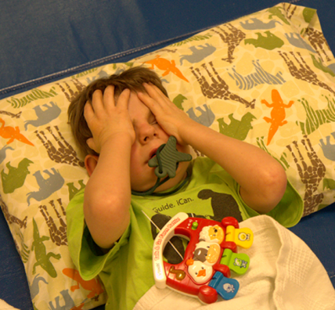
Figure 12 A young child covers his eyes and chews on a rubber shape while he lies on the floor.

About these Forms
The forms included in this document are designed to capture typical data collected by a team along with specialized information that is critical for a student who is deafblind or has visual and multiple impairments. We encourage all teams to consider all the questions that are included as they take into consideration the specialized needs of the child who is deafblind or has visual and multiple impairments.
Teams should be proactive in supporting the social and emotional development of these children who are deafblind or has visual and multiple impairments. They do this by providing quality intervention and instruction developed for the specific unique strengths, preferences, and challenges of the child. We consider these to be Tier 2 level interventions and supports.
However, sometimes, additional responsive intervention is needed after implementing Tier 2 level interventions and supports. This occurs when the child continues to show signs or escalates to extreme distress and exhibits behaviors that are self-injurious, highly disruptive or can hurt others. At this point, the educational team typically develops a formal Behavior Intervention Plan (BIP). Most school district have standard processes and forms they use for this purpose.

For the Tier 3 Student – A note to the assessor
During creation of a Behavior Intervention Plan, a Function Behavior Assessment (FBA) will be completed. Traditionally, the functions of behaviors identified fall into a few common motivations, such as gaining attention or tangible items, or rejecting activities and situations. Some formats lead assessors to select motivations such as control, escape, revenge, attention seeking, or sensory stimulation.
However, these frequently identified functions do not include recurrent explanations of distress leading to behaviors that are not as purposeful in the same way. Many students who blind or deafblind with additional disabilities may respond to distress related to sensory, emotional or physical complications, past experiences of perceived adversity; difficulty being understood when expressing concerns, or other factors unrelated to the motivations found on FBA checklists.
The underlying factors leading to behavioral episodes for students who are deafblind or visually impaired with additional disabilities often might include:
- Distress from being repeatedly misunderstood when expressing needs, choices, or concerns.
- Confusion/anxiety from receiving incomplete, distorted or fragmented information.
- Panic (fight, flight, freeze) response to something perceived as threatening.
- Situations or circumstances that remind the student of a past trauma or adverse experience.
- Managing physical difficulties such as balance problems, instability, glare, or noise.
- Masking other physical or emotional pain.
- Feelings of isolation or loneliness.
- Regret, grief, or loss.

Step 1 - Clarify Information about Concerns
Clarity and consensus on the specific distressed behaviors that concern the team is important. So the very first step for a team is to meet to identify their specific concerns, how frequently these behaviors are occurring, what interventions are currently being used, and under which circumstances these distressed behaviors are observed.
- Identify problems or areas of concern:

- How frequently would you estimate this problem(s) occurs?
- What interventions have been tried by you or others in the past? Have they been effective? Why do you think they are not working now?
- In what settings and under what conditions do you observe the behavior? (check all that apply and give brief description)

At a change of routine:
At mealtimes:
At the completion of a favorite activity:
At the completion of a non-preferred activity:
During new activity:
During unstructured time:
During certain times of day:
During certain academic tasks:
During transitions:
During certain weather conditions:
In crowded areas:
In noisy areas:
In new or unfamiliar environments:
Other:

- Are any particular individuals consistently present when the behavior occurs? Who?
- What activities or interactions take place just prior to the behavior?
- What activities or interactions take place immediately following the behavior?
- Are there other behaviors that occur along with the problem behavior? What?
- Can you think of any reasons why the child might behave this way?
- What would be a more acceptable way for the child to achieve the same outcome?

Conclusion Summary for Step 1:
What has your team learned? Is everyone on the team clear about what the specific behavioral issues look like, where they are most likely to occur, and why current interventions are or are not working? Summarize your conclusions. Summarize important findings below:

Step 2 – Gather Additional Information
Gathering information that will help the team use proactive strategies in programming for the student is another critical step. Identifying learner preferences, areas of strength and need, and calming activities included in the child’s current program is an important place to start. Redesigning programming to include proactive strategies is important.
- What are the child’s favorite activities?
- What are the child’s least favorite activities?
- What strengths are noted in the Present Levels of Academic Achievement and Functional Performance (PLAAFP) for this child?
- What are the prioritized areas of need noted in the Present Levels of Academic Achievement and Functional Performance (PLAAFP) for this child?
- In general, do you feel the academic demands on this child are appropriate and neither too easy nor too hard? If not please explain.
- Have you identified any reinforcing circumstances or items that may effectively motivate the child? What are these?
- What environmental and/or instructional modifications should be considered when planning for this child?
- Does the child participate in calming activities or routines and get sufficient exercise as part of his daily activities?

Conclusion Summary for Step 2:
What has your team learned? Summarize important findings below:

Step 3 – Gather Basic Health Considerations and Other Issues
Children who are deafblind or have visual and multiple impairments often have additional disabilities and medical issues. Many children take medication that affects their overall functioning. Some genetic conditions make the child extremely vulnerable to anxiety and exaggerated stress responses. It is critical to rule out health concerns as the source of behavioral concerns or distressed behavior. These questions should be considered before developing any Behavior Intervention Plan for a student who is deafblind or has visual and multiple impairments.
- What is the child’s etiology and does it put him/her at risk for intense anxiety?
- What type of vision loss does the child have and how might it be affecting the behavior? Is there any evidence of medical issue related the eye condition (e.g. high intraocular pressure, retinal detachment, infection) and what is it?
- What type of hearing loss does the child have and how might it be affecting the behavior? Is there any evidence of medical issues related to his ears or hearing (e.g. ear infection, ear drum perforation) and what is that evidence?
- What other disabilities or medical conditions may be affecting his/her behavior and how?
- Is the child taking medications that may be causing problems? What are they, and what side effects might occur?
- Is the child sleeping, eating, and eliminating normally? If not, what is the problem?
- Does the child exhibit any particular behaviors that might be indicative of pain (slapping an ear, rubbing an eye, rubbing stomach) and what are they?
- Are there any unusual events or circumstances occurring at home or within the family that might be causing the child emotional distress or confusion? What are these? For example, has there been a death or separation from a parent, a recent loss of vision, relocation of a close friend?

Conclusion Summary for Step 3:
What has your team learned? Summarize important findings below:

Step 4 – Review the current program
The list of questions below is intended to help the team reflect on the child’s current program when developing specific interventions and supports at the Tier 2 level. Review the questions included in this chart to help guide your team’s discussion about proactive strategies (Tier 2). All programs should include the proactive strategies.

Proactive Strategies for Fostering Feelings of Safety (Tier 2)
Proactive strategies fostering feelings of safety | Questions to about programming | Yes | No | Sometimes | Comments
Spend time with the child and observe their movements | Is there time set aside in the child’s schedule for staff interaction?
 | Is there time set aside to observe the child in independent play?
 | Is there a system for observing and documenting or recording observations of the child in both interactive and independent play?
Be in close proximity to the child | Does the child have opportunities to be in close proximity to adults and/or peers?
 | Is the child allowed access to adult and peers hands (using hand-under-hand) for modeling exploration and use of materials in the environment?
 | Is the child’s request to move away from others for short periods of time respected?
 | Does staff ask for permission to touch the child during care-giving and other activities and provide appropriate wait time for the child to consent?

Proactive strategies fostering feelings of safety | Questions to about programming | Yes | No | Sometimes | Comments
Follow the child’s lead | Does the child indicate interest in an activity or interaction? How?
 | Do adults recognize the child’s interests and respond by sharing attention, encouraging and supporting the child’s interest? How?
 | Does staff provide appropriate vocabulary to name the child’s interests in a format that is accessible to the child?
 | Does staff take turns with the child when engaging in an activity or with an object of interest?
Mark your entries and exits from the child’s world with greetings and parting rituals | Do team members greet the child in a way that lets the child they know who they are? How?
 | Do varied members of the team have varied greetings?
 | Do team members always let the child know that they are leaving?
Acknowledge the child’s emotions and share yours with them | Does staff understand the emotions the child express with the face?
 | Does staff understand the emotions the child express with their arms, legs, head and neck?
 | Does staff understand the emotions the child express with sounds?
 | Does staff understand the emotions the child express with words?
 | Is staff consistently responsive to the emotions expressed by the child?
 | Do you let the child know that you are aware of he/she is feeling? How?
 | Do you share your emotions with a blind child or a child with low vision? How?
Establish turn taking routines | Does the child participate in regularly scheduled routines involve turn-taking?
 | Can turn-taking be infused into existing routines that lack it?

Summary
What Tier 2 Strategies should be added or expanded in the child’s current program?

Proactive Strategies for Fostering Feelings of Success (Tier 2)
Proactive strategies fostering feelings of success | Questions to about programming | Yes | No | Sometimes | Comments
Design activities based on the child’s interest | Has the team identified (with the inclusion of parent input) preferred objects, movements, activities and people?
 | Are these preferences incorporated into every part of the child’s day as much as possible?
 | Is novelty introduced slowly and sparingly based on these identified interests?
 | Are non-preferred objects, movements, activities and people minimized as much as possible?
Provide many opportunities for the child to explore and experiment with objects and materials | Does the child spend some time every day in activities and environments where he can play independently with minimal intervention of an adult?
 | Is the child allowed to explore and experiment with objects in any way he chooses without correction from an adult? (Note: accommodations may be required if the child’s methods of exploration and experimentation create safety concerns.)
 | When adults are included in activities with the child do they use techniques such as hand-under-hand, imitation, and turn-taking while exploring and experimenting with objects and materials?
Utilize an appropriate calendar system that stays in a defined location | Has the appropriate level of calendar system been set up in a defined location for the child? (See Calendars for Childs with Multiple Impairments Including deafblindness, by Robbie Blaha)
 | Is the calendar system used throughout the day as the child moves from one activity to another?
 | Does staff engage in conversations about activities and experiences using the calendar system at the beginning and end of each activity?
 | Does the child have independent access to his calendar system throughout the day to request or reject specific activities? Introduce topics for discussion?
Provide only the support needed by the child so he/she learns to cope with successes and failures. | Does staff provide adequate “wait time” for the child to attempt an action or response during all activities?
 | Does the staff know the child’s specific skills to ensure they do not carry out a step the child is capable of completing independently?
 | Does the staff utilize modeling (especially tactile modeling) when providing necessary support as much as possible?
Respond to distress immediately by increasing support and redirecting. | Does staff change pace, reduce demands or expectations when a child becomes frustrated?
 | Does staff provide more information to the child?
 | Does staff increase physical assistance to help the child complete or continue an activity?
 | Does staff suggest or demonstrate calming strategies when the student becomes frustrated?

Summary
What Tier 2 Strategies should be added or expanded in the child’s current program?

Proactive Strategies for Fostering Feelings of Independence (Tier 2)
Proactive strategies fostering feelings of independence | Questions to about programming | Yes | No | Sometimes | Comments
As much as possible do “with not for” when engaging the child | Are written routines shared among team members to insure consistent steps?
 | Is the level of support needed to successfully complete the routine included?
Designate specific areas of the classroom to store belongings and for doing regular activities | Does the child have a designated spot to store their cane or other personal items?
 | Does the child have an area set aside where calendar conversations take place?
 | Do instructional routines occur is consistent locations?
Support the development of the child’s expressive forms of communicating | Are all team members aware of the child’s expressive communication forms? What are these forms?
 | Are all team members aware of how the child’s vision and hearing loss impact their ability to detect and gather information?
As much as possible, allow the child to make choices about activities and the daily schedule. | Does the child have opportunities to make choices within routines and activities?
 | Does the child have opportunities to make choices about his/her schedule?
 | Does the child have opportunities to reject an activity or request an end to an activity?

Summary
What Tier 2 Strategies should be added or expanded in the child’s current program?

Proactive Strategies for Fostering Feelings of Connectedness (Tier 2)
Proactive strategies fostering feelings of connectedness | Questions to about programming | Yes | No | Sometimes | Comments
Develop a communication system that allows for reciprocal communicative interaction | Are staff and peers able to identify and understand the child’s expressive communication?
 | Does staff facilitate interactions between the child and peers or other adults so they know what the child is interested in sharing?
 | Does staff facilitate interactions between the child and peers or other adults so they can share what interests them?
 | Does staff feel confident in determining when to include peers and others in specific activities?
Acknowledge and record meaningful experiences in books or story boxes to share with others. | Does staff collect objects, pictures and/or other materials from the child’s experiences?
 | Is the student provided opportunities to coactively make storybooks or boxes from these materials with staff and/or family?
 | Does staff and/or family take time daily to review at least one of these books or boxes with the child?
 | Are storybooks or boxes maintained throughout the year and available for the child to access independently?
Build connections through membership in a community. | Does the child have opportunities to contribute to class and family chores?
 | Does the child participate in class or family traditions, rituals, and special events?
 | Does the child have a “positive specialized identity” (e.g., the girl who brings cupcakes, the boy who loves to dance, the child who makes silly sounds) that enriches his self-identity?
 | Does the child make (or could he make) contributions that are perceived as positive by his community?

Summary
What Tier 2 Strategies should be added or expanded in the child’s current program?

Conclusion summary for Step 4:
Summarize important findings related to proactive strategies (Tier 2) being used or not being used in the current program below:

Step 5 – List of Intervention and Supports – Tier 2
Everyone who works with the student needs to be clear and consistent about is needed to proactively support the student. Note what is expected of the adults working with the student in the chart below. Make sure to share this chart with all team members and others who interact with the student.
Proactive strategies | What does the adult do?
Spend time with the child and observe their movements
Be in close proximity to the child
Follow the child’s lead
Mark your entries and exits from the child’s world with greetings and parting rituals
Acknowledge the child’s emotions and share yours with them
Establish turn taking routines
Proactive strategies | What does the adult do?
Design activities based on the child’s interest
Provide many opportunities for the child to explore and experiment with objects and materials
Utilize an appropriate calendar system that stays in a defined location
Provide only the support needed by the child so he/she learns to cope with successes and failures.
Respond to distress immediately by increasing support and redirecting.

Proactive strategies | What does the adult do?
As much as possible do “with not for” when engaging the child
Designate specific areas of the classroom to store belongings and for doing regular activities
Support the development of the child’s expressive forms of communication
As much as possible, allow the child to make choices about activities and the daily schedule.
Proactive strategies | What does the adult do?
Develop a communication system that allows for reciprocal communicative interaction
Acknowledge and record meaningful experiences in books or story boxes to share with others.
Build connections through membership in a community.

Step 6 - Taking Data on Observable Behaviors
Taking data is key to the development and refinement of any intervention. You may not know if changes to your intervention and supports (at the Tier 2 level) are working without this information. Note: In most cases you see an increase in the behaviors initially, but with consistent use of the proactive strategies you should begin to see improvement. Take data at various times and during various activities throughout the day. After an agreed upon timeframe (e.g. 6 weeks), the team may need to reconvene to develop responsive strategies at the Tier 3 level, that is a formal Behavioral Intervention Plan (BIP).
Child: Date:
Behavior & initials of adult taking data | Activity and possible trigger(s) | Intensity rating | Time & Duration of Occurrence | Were appropriate supports & interventions used? |  | If YES, did supports or interventions lessen the behavior?
 |  |  |  | Yes | No | Yes | No
1 2 3 4 5
6 7 8 9 10
1 2 3 4 5
6 7 8 9 10
1 2 3 4 5
6 7 8 9 10
1 2 3 4 5
6 7 8 9 10
1 2 3 4 5
6 7 8 9 10
1 2 3 4 5
6 7 8 9 10
1 2 3 4 5
6 7 8 9 10
1 2 3 4 5
6 7 8 9 10
1 2 3 4 5
6 7 8 9 10
1 2 3 4 5
6 7 8 9 10
1 2 3 4 5
6 7 8 9 10
1 2 3 4 5
6 7 8 9 10
1 2 3 4 5
6 7 8 9 10
1 2 3 4 5
6 7 8 9 10
1 2 3 4 5
6 7 8 9 10
1 2 3 4 5
6 7 8 9 10

Step 7 – Tier 3 Responsive Intervention and Supports
Some students may need more intervention and support than has been provided at the Tier 2 level. Reflecting on the data you have taken over a period of time (e.g. 6 weeks) determine if this is the case. The team may determine that additional intervention and support at a Tier 3 level are needed and begin to develop a formal behavior intervention plan.
Before developing this plan, review the questions below to guide you in developing these additional intervention and support strategies (Tier 3). These usually are needed only when proactive strategies are being used completely and the child is still demonstrating signs of distress.
Once you have reviewed the questions, the team can determine which additional strategies should be used to support the child. These additional strategies most often are included in a formal intervention plan.
Your district may have established procedures for developing the behavioral intervention plan. In some instances, there may be a web-based program used for developing plans. Therefore, a report outlining specific strategies may need to be included in the child’s individual education plan similar to the form found on pages 51-52.
Responsive strategies fostering feelings of safety | Questions to ask about programming | Yes | No | Sometimes | Comments
Minimize contact with people, places, or things that trigger behavior problems. | Does all staff minimize contact with known triggers?
Alter materials or the environment to discourage less appropriate behaviors. | Does staff change materials that seem to lead to inappropriate behaviors?
 | Does staff change the environment or location of an activity that seems to cause distress?
Alter activity schedules to reduce stress. | Does staff allow the student to choose an alternative activity as much as possible?
 | Does staff allow the schedule to be flexible when the child is having a difficult day?
Be aware of signs that indicate potential problems and make necessary modifications. | Is all staff aware of the early signs of distress the student shows?
 | Do they feel comfortable making changes as needed to reduce the distress?
Make sure there is structure, routine and predictability throughout the child’s school day. | Does the staff provide a predictable structure throughout the school day?
 | Are unexpected changes avoided? When they occur does the staff have a way of clearly letting the child know a change needs to occur?
 | Is the staff able to communicate that indicate a preferred activity must wait or be cancelled?

Summary
What Tier 3 Strategies should be added or expanded in the child’s current program?
Responsive strategies fostering feelings of success | Questions to ask about programming | Yes | No | Sometimes | Comments
Increase the level of support so the child is not frustrated by difficult activities | Has the team reviewed “Determining the Need of an Educational Intervener”?
 | Is appropriate support provided in all activities throughout the day? (Note this may vary depending on the activity, dynamics of the group or environment, etc.)
 | Is the team comfortable in evaluating the student’s state to reduce or increase support as needed?
Deliver information to the child in a form that is accessible, understandable and accurate | Is the team able to deliver information in the child’s receptive language mode? (gestures, signals, signs, speech) What are they?
 | Does the child have an established static literacy mode? What is it (objects, tactile symbols, pictures, print and/or Braille)?

Summary
What Tier 3 Strategies should be added or expanded in the child’s current program?
Responsive Strategies fostering feelings of independence | Questions to ask about programming | Yes | No | Sometimes | Comments
Teach coping skills and provide opportunities to practice these skills in structured and safe environments | Does the child currently use some coping skills when feeling distressed? What are they?
 | Does staff teach strategies to help the child regulate their emotional state when the child becomes distressed (e.g. yoga, deep breaths, counting)? Does the child practice these regularly?
 | Does the staff respond with encouraging gestures of support and positive personal affect to the child’s attempts to participate or self-regulate?
Provide direct instruction in social skills | Are appropriate social skills modeled for the child? In what ways and in what activities?
 | Could the child benefit from role play activities to learn and practice social skills?
Demonstrate the emotional state you want the child to achieve. | Is staff aware of their emotional state when interacting with the child? If they had formal language, how would the child describe your regular emotional state?
 | Is that the state that you wish to share with the child? How could you change that emotional state?

Summary
What Tier 3 Strategies should be added or expanded in the child’s current program?
Responsive strategies fostering feelings of connectedness | Questions to about programming | Yes | No | Sometimes | Comments
Encourage participation through the projection of a positive affect | Does staff model enjoyment and enthusiasm about the activity they share with the child?
 | Does the staff use tactual as well as other means to communicate enthusiasm and encouragement to the child?
 | Do staff celebrate small milestones with the student through gestures (e.g. high five), signs (e.g. yes, that’s great), and other methods (e.g. jumping for joy)?

Summary
What Tier 3 Strategies should be added or expanded in the child’s current program?

Step 8 – List of Intervention and Supports – Tier 3
As before, any new strategies for intervention and support must be used appropriately and consistently by everyone interacting with the child. Note the strategies in the chart below that the adult should be using with the child. Make sure that this information is shared with all team members and others who interact with the student.
Responsive strategies fostering feelings of safety | What does the adult do?
Responsive strategies fostering feelings of safety
Minimize contact with people, places, or things that trigger behavior problems.
Alter materials or the environment to discourage less appropriate behaviors.
Alter activity schedules to reduce stress.
Be aware of signs that indicate potential problems and make necessary modifications.
Make sure there is structure, routine and predictability throughout the child’s school day.
Responsive strategies fostering feelings of success | What does the adult do?
Increase the level of support so the child is not frustrated by difficult activities
Deliver information to the child in a form that is accessible, understandable and accurate
Responsive strategies fostering feelings of independence | What does the adult do?
Teach coping skills and provide opportunities to practice these skills in structured and safe environments
Provide direct instruction in social skills
Demonstrate the emotional state you want the child to achieve.
Responsive strategies fostering feelings of connectedness | What does the adult do?
Encourage participation through the projection of a positive affect

Step 8 - Behavior Intervention Plan
Most school districts have specific forms that are used for developing a formal behavioral intervention plan that will list the specific interventions that should be provided when working with the child in order to:
- prevent the identified behavior from occurring,
- guide intervention when the distressed behavior is occurring, and
- provide intervention following an incident of the behavior.
Whatever form on online system is used to develop such a plan, it is critical that the Tier 3 level interventions and supports you have identified are included.
An example of how this information might be included in a formal Behavior Intervention Plan can be found on pages 56-61.

Step 9 - Take Data on Observable Behaviors
Take data at various times and during various activities throughout the day. After an agreed upon timeframe (e.g. 6 weeks), the team should review the data from the Tier 3 interventions and supports and decide whether new or additional interventions and supports are needed. Note: Children frequently exhibit an increase in distressed behaviors initially, so it is important to consistently use agreed upon interventions and supports for a reasonable length of time (e.g. 4 weeks) before making additional changes to the formal behavior intervention plan.
Child: Date:
Behavior & initials of adult taking data | Activity and possible trigger(s) | Intensity rating | Time & Duration of Occurrence | Were appropriate supports & interventions used? |  | If YES, did supports or interventions lessen the behavior?
 |  |  |  | Yes | No | Yes |  | No
1 2 3 4 5
6 7 8 9 10
1 2 3 4 5
6 7 8 9 10
1 2 3 4 5
6 7 8 9 10
1 2 3 4 5
6 7 8 9 10
1 2 3 4 5
6 7 8 9 10
1 2 3 4 5
6 7 8 9 10
1 2 3 4 5
6 7 8 9 10
1 2 3 4 5
6 7 8 9 10
1 2 3 4 5
6 7 8 9 10
1 2 3 4 5
6 7 8 9 10
1 2 3 4 5
6 7 8 9 10
1 2 3 4 5
6 7 8 9 10
1 2 3 4 5
6 7 8 9 10
1 2 3 4 5
6 7 8 9 10
1 2 3 4 5
6 7 8 9 10
1 2 3 4 5
6 7 8 9 10
1 2 3 4 5
6 7 8 9 10

Sample of Information to include in the Behavior Intervention Plan
This document is an example of how to be proactive (Tier 2) in supporting Joan’s social and emotional development by providing quality intervention and instruction developed for Joan’s unique strengths, preferences, and challenges. Additionally, responsive strategies (Tier 3) are suggested for use when the student is having particular difficulty in managing her distressed behavior.
This list comes from the forms generated in the Behavioral Intervention and Support for Children and Young Adults who are Deafblind or have Visual and Multiple Impairments. They create a list of behavior strategies that may be added to a student’s IEP. By creating a Word Document, a team has the flexibility to use individual styles and formatting that can supplement typical checklist or online forms.

Strategies to Support Behavior/Distress
Student: Joan

Clarifying concerns:
After completing the forms from Behavioral Intervention and Support for Children and Young Adults who are Deafblind or Visual and Multiple Impairments the team has compiled the following information.
- Physical aggression towards self:
- Joan exhibits the following signs of distress: scratching her face, hitting her legs, pinching her arms and neck, attempting to bang her head against surfaces.
- Physical aggression towards others:
- Joan exhibits the following signs of distress that she directs towards others: hitting, kicking, throwing objects, pulling hair, attempts to bite or head butt.

Additional information related to her specific disabilities
After responding to the questions in Behavioral Intervention and Support for Children and Young Adults who are Deafblind or Visual and Multiple Impairments, the team felt the following were important factors that contribute to moments of distress:
- Joan has light perception on in her right eye and low vision in her left eye. She has a profound hearing loss. The combined effects of Joan’s vision and hearing loss make it difficult for her to access information about what is happening around her. This affects her ability to communicate, anticipate events, and understand other’s expectations of her.
- Joan was born with agenesis of the corpus callosum. She takes medicine for attention deficit hyperactive disorder, and a seizure disorder. She had corneal transplants in both eyes and has extremely dry eyes that require lubricant drops about every hour for protection. She has a habitual cough that worsens in the springtime, as she is allergic to mold. Joan travels with her walker and moves well but her shaky movements combined with her visual impairments can sometimes cause her to be off balance.
- Joan’s family reports she has difficulty settling down at night and sleeping in a room by herself. She demonstrates anxiety near bedtime and typically sleeps 4-5 hours.
- Joan is very interested in her peers and wants to interact with them but lacks the appropriate social skills to do so. She often becomes overstimulated around other students especially in crowed or confusing environments. Sometimes she hits or throws things to interact with others or get their attentions. Joan tends to target certain staff or students she likes or is interested in.
- Sometimes Joan has a difficult time at the competition of activities, especially if it is an exciting or stimulating activity. She has difficulty moving on to the next activity.
- Some of Joan’s distress happens when there is unstructured time.
- Joan becomes attached to staff and has a hard time switching back and forth between different people. She becomes confused sometimes when she doesn’t know whom she is supposed to be paying attention to and working with.
- During certain weather conditions such as windy days, when traveling outdoors, Joan may experience distress. If the wind causes Joan to become off balance, she may smile or laugh followed by self-abuse or aggression.

Summary of conclusions
Joan experiences moments of distress which potentially can be explained by:
- being repeatedly misunderstood when expressing needs, choices, or concerns
- confusion/anxiety from receiving incomplete, distorted, or fragmented information
- panic
- balance difficulties, glare (physical difficulties)
- physical and/or emotional pain
- feelings of isolation, loneliness, regret, grief, etc.
Sources of data:
- Review of records
- Observation
- Information from instructional team
- Information from family

Recommendations
Using the Behavioral Intervention and Support for Children and Young Adults who are Deafblind or have Visual and Multiple Impairments the team determined that many of the Tier 2 proactive strategies are currently being used to support Joan, but some strategies have not been implemented or implemented consistently. The team will continue to implement these specific Tier 2 strategies. Additional Tier 3 responsive strategies are included to address episodes of extreme distress.

Proactive Strategies (Tier 2) Fostering Feelings of Safety
- Follow the child’s lead
- Provide activities based on her interests and infuse turn taking, conversation (on her language level), and teach necessary vocabulary to allow her to request these activities as well as have conversations with others about her topics of interest. Look for opportunities to follow Joan’s lead.
- Mark your entries and exits from the child’s world with greetings and parting rituals
- Mark entries and exits from Joan’s world with greetings and parting rituals that are consistent and specific to each person.
- Acknowledge the child’s emotions and share yours with them
- Acknowledge Joan’s emotions expressed by her body language and facial expressions in ways that teach her about managing her emotions without causing further distress. Conversations about emotions related to her distress should not occur during times when she is experiencing distress.

Responsive Strategies (Tier 3) Fostering Feelings of Safety
- Alter activity schedules to reduce stress.
- Decrease length of time of activity or allow Joan to watch the end of an activity rather than continue to participate, and/or accept partial participation.
- Take a time-out to practice stress-reducing yoga activities; then try to resume routine.
- Make sure there is structure, routine and predictability throughout the child’s school day.
- Joan needs a consistent routine for each activity she engages in so that she can anticipate what is happening and feel more comfortable. This includes for example, riding in the van, nighttime routines, shopping, laundry, meals, calendar, school day activities and leisure time.
- Each routine should have a clear beginning and ending and it is often best to represent each step with a picture or photo. For example, when Joan makes tacos, the first step is always to grate the cheese, and the last step is to wash the dishes and place the dishes in the drying rack. All of the steps in between are in the same order each time she participates in the activity.
- When Joan has OT class, she does the same sequence of activities each time: 1.) Spin in the egg chair; 2.) Spin on the spin board; 3.) Rock on the rocker board; 4.) Roller skate; 5.) Swing. Each of these steps is represented by a photograph. In music class, Joan first plays the guitar, then plays the accordion and finishes by playing the drum.
- Novelty and changes to the routine should be added gradually (once the routine is established) by showing the changes to Joan using pictures, and simple sign language.
- For activities that do not have a clear beginning or ending, such as computer time or playing with the Wii, teach Joan a way to mark time such as setting a timer for herself.

Proactive Strategies (Tier 2) Fostering Feelings of Success
- Design activities based on the child’s interest.
- When Joan is engaged in interesting activities, she is less likely to have problems with behavior. Activities such as work, cooking, music, art, and PE have rarely been a problem for Joan. Look for opportunities to infuse Joan’s interests into consistent routines. Joan likes to be busy and enjoys a wide variety of activities such as simple crafts, looking at experience stories she has helped to create, simple cooking.
- Staff should provide direct instruction on recreation and leisure activities based on Joan’s interests. She should be given time during her day to make choices and participate in these types of activities toward the goal of accessing them during unstructured time.
- Provide many opportunities for the child to explore and experiment with objects and materials.
- During independent play, let Joan explore and experiment with objects and materials she will use in other situations and activities. Let her explore in any way she chooses. This is a way to introduce novelty slowly without making any specific demands on the child to perform in a specific manner.
- Utilize an appropriate calendar system that stays in a defined location.
- Use calendar systems with real photographs and pictures that have been drawn with Joan. Use a daily calendar and 2-week calendar to give Joan important information about her schedule (daily schedule, choice time, weekly activities and trips in the community).
- Keep it in a defined location so she can learn to move towards it independently when requesting information and conversations as it helps to clarify and identify her wants and needs.
- Return to the calendar between each activity to “finish” previous activity and discuss what is next, whenever possible. If unable to return to calendar, carry pictures with you to allow discussion of each activity so Joan is sure of her next destination.
- Provide only the support needed by the child so he/she learns to cope with successes and failures.
- Make sure she has information about where she is going and whom she’ll be working with before transitions from one activity to the next.
- Attach a photograph or picture to on her walker using Velcro strips to give her information about her next activity. Although Joan can understand many signs, she has difficulty following signed instruction while walking due to her balance.
- Engage in expectant waiting to help signal Joan that it is her turn, and has enough time to attempt an action, process information, and respond.
- Provide structure and guidance when introducing new routines. Joan needs this support to be successful. Expectations about her role are very important and need to be thought through ahead of time. Materials should be set up and in place before starting any activity.
- Remind her of coping strategies she might use if she needs a break, such as her yoga routines.

Responsive Strategies (Tier 3) Fostering Feelings of Success
- Increase the level of support so the child is not frustrated by difficult activities
- Sign “help” to let Joan know she can request assistance when she begins showing signs of frustration.
- Deliver information to the child in a form that is accessible, understandable and accurate
- Use calendar systems with real photographs and pictures that have been drawn with Joan.
- Provide consistent sign language vocabulary at her level.
- Redirect Joan with a picture or by pointing to what she’s supposed to be doing. In some situations, fingerspelling can help calm Joan, but lots of animated signing or facial expressions usually causes more distress.

Proactive Strategies (Tier 2) for Fostering Feelings of Independence
- As much as possible do “with not for” when engaging the child
- Provide adequate “wait time” before offering help when Joan does not engage with a person or activity.
- Designate specific areas of the classroom to store belongings and for doing regular activities
- Provide a consistent location within each instructional environment where Joan can park her walker.
- Keep the location of specific activities consistent from day to day.
- Develop a communication system that allows for reciprocal communicative interaction
- Joan’s team should continue to evaluate how often conversations are adult-led. Allow time and provide appropriate materials so that conversations can become balanced or reciprocal.
- Acknowledge and record meaningful experiences in books or story boxes to share with others.
- Provide opportunities for experience stories to be shared with familiar staff who are able to communicate with Joan both expressively and receptively.
- As much as possible, allow the child to make choices about activities and the daily schedule.
- Give Joan time during her day to make choices and participate in preferred recreation and leisure activities toward the goal of accessing them during unstructured time.
- Incorporate opportunities for choice-making within familiar routines and activities.
- When scheduling the day in her calendar system, allow Joan to have some flexibility in choosing the sequence of activities. For example, when two activities are scheduled back-to-back in her classroom, let her determine which activity she will do first.

Responsive strategies (Tier 3) for independence
- Teach coping skills and provide opportunities to practice these skills in structured and safe environments
- Make time each day for Joan to practice her yoga routine in a structured and safe environment. For Joan, this is an example of a coping skill.
- Encourage Joan to express her feelings with words when she starts to feel frustrated or upset.
- Encourage Joan to ask for “help” or request a break when she starts to feel frustrated or upset.
- Provide direct instruction in social skills
- Model appropriate social skills by using cross talk with other staff. For example, asking for help from another staff member to complete a task.
- Provide direct instruction in social skills by using scripts that allow Joan to communicate with others during routines. Such as during the routine in which she makes and sells tacos, “hi” “do you want to buy a taco?” “thank you”.
- Demonstrate the emotional state you want the child to achieve.
- When you sense that Joan is becoming distressed be sure to interact with her in a calm and deliberate manner.
- Be very mindful of your pacing.
- Demonstrate using some of the yoga breathing techniques she knows that may help her self-regulate.

Proactive Strategies (Tier 2) for Fostering Feelings of Connectedness
- Develop a communication system that allows for reciprocal communicative interaction
- Facilitate interactions between Joan and her peers (especially those she demonstrates some interest in).
- Acknowledge and record meaningful experiences in books or story boxes to share with others.
- Coactively collect materials from Joan’s experiences and build consistent times to make and share experience stories.
- Build connections through membership in a community.
- Assist Joan in making gifts for others (birthdays and holidays).
- Encourage her to share experience stories with a favorite peer or staff who are able to communicate with her both expressively and receptively.

Responsive Strategies (Tier 3) for Fostering Feelings of Connectedness
- Encourage participation through the projection of a positive affect
- Model enthusiasm and enjoyment about shared activities.
- Celebrate milestones with Joan through high fives and positive language like “you did ____!” “Yay!”

Texas School for the Blind & Visually Impaired
Outreach Programs

Figure 13 TSBVI logo

This project is supported by the U.S. Department of Education, Special Education Program (OSEP). Opinions expressed here are the authors and do not necessarily represent the position of the Department of Education.
Figure 14 IDEAs that Work logo.

